The LaMar Origin of the Garner Line

*A Y-DNA and Documentary Research Summary*

Establishing the Biological Paternity of

**Rev. William Garner (c. 1745-1824)**

C. Edwin Garner, Ph.D.

December 2025

# Executive Summary

This research document presents conclusive Y-DNA evidence, combined with documentary analysis, establishing that Rev. William Garner (c. 1745-1824) of Brunswick/Greensville County, Virginia and Northampton County, North Carolina was the biological son of Thomas LaMar (d. 1747) of Prince George's County, Maryland. The Garner surname was acquired through his mother, likely an illegitimate birth, while his biological paternal line descends from the documented LaMar family of colonial Maryland, ultimately tracing to Thomas Lamar, Sr. (1630/1641-1714), a French Huguenot immigrant.

## Key Findings

1. **Y-DNA Match Confirmed:** A 700-marker Y-DNA test reveals a genetic distance of only 3 between the Garner and LaMar lines, with a >95% probability that the common ancestor was born c. 1750.
2. **Samuel Garner Y-DNA Confirmation:** A complete 11-marker Y-DNA match between Rev. William Garner Sr.'s line and a descendant of Samuel Garner confirms both men were biological sons of Thomas LaMar, establishing them as brothers.
3. **Documentary Alignment:** William Garner's birth (c. 1745) aligns precisely with the death of Thomas LaMar (1747) and the subsequent orphans court proceedings (1748-1765) in Frederick County, Maryland.
4. **Will Evidence:** Thomas LaMar's 1747 will names a "son-in-law William"—colonial terminology for an adopted son, stepson, or acknowledged illegitimate child—distinct from his five legitimate sons.
5. **Naming Pattern:** Rev. William Garner's 1824 will includes an enslaved man named "Lamar"—a highly unusual name suggesting acknowledgment of his biological origins.
6. **Geographic Proximity:** Multi-generational proximity between Garner and LaMar families along the Patuxent River in colonial Maryland establishes opportunity for the biological connection.
7. **Revolutionary War Service:** Documentary evidence establishes distinct Revolutionary War service for Rev. William Garner, corroborated by matching 6-pound payment records in both Virginia and North Carolina archives—reflecting his unique cross-border property holdings.
8. **Family Network Identified:** A coherent "South of Meherrin" Garner clan has been identified, including Rev. William Garner Sr., Samuel Garner, and Presley Garner—distinct from William Garner (d. 1805 KY) who lived north of the Meherrin.
9. **Geographic Evidence Confirmed:** Civil War era Gilmer Maps identify four Garner plantation sites near Gaston, NC. Field investigation confirmed two sites with cemeteries containing graves of Rev. William Garner Sr.'s descendants, including Dr. Presley Killingsworth Garner (1835-1861).

# Section 1: Y-DNA Evidence

## 1.1 The Y-DNA Match

Y-chromosomal DNA (Y-DNA) passes from father to son virtually unchanged across generations, making it an ideal tool for tracing patrilineal ancestry. A comprehensive 700-marker Y-DNA test was conducted, revealing a significant match between the Garner and LaMar lines.

### Match Parameters

|  |  |
| --- | --- |
| **Parameter** | **Value** |
| Markers Tested | 1 to 700 |
| Genetic Distance | 3 steps |
| Big Y STR Differences | 5 of 676 |
| Y Haplogroup | J-FTD69292 |
| Paternal Country of Origin | United States |

### Tested Individuals

|  |  |  |
| --- | --- | --- |
| **Individual** | **Birth Year** | **Oldest Known Ancestor** |
| C. Edwin Garner | 1966 | William Garner (c. 1745-1824) |
| Walter Milton LaMar | 1919 | William Samuel LaMar (b. 1799)* |

*\*The documented LaMar pedigree extends to Thomas Lamar, Sr. (1630/1641-1714) of France and Maryland.*

## 1.2 Genetic Distance Analysis

Based on a Genetic Distance of 3 at the Y-111 test level, the estimated common paternal ancestor was born between 1600 and 1900 CE with 95% probability. The most likely year, based on genetic information alone, is **approximately 1750 CE**.

This genetic estimate aligns remarkably with the documentary evidence, which points to a divergence occurring in the generation of Thomas LaMar (d. 1747) and his contemporary William Bishop LaMar (b. 1745).

## 1.3 Interpretation of Y-DNA Results

The Y-DNA evidence is unequivocal: the Garner line carries LaMar Y-DNA. Since Y-DNA passes strictly from biological father to biological son (paralleling surname transmission in most Western cultures), this means that somewhere in the Garner patrilineal ancestry, a biological LaMar fathered a child who carried the Garner surname.

The critical question becomes: *at what generation did this occur?*

* The Garner paper trail dead-ends in the 1750s
* The genetic common ancestor estimate centers on 1750
* The LaMar line is documented continuously from 1630/1641 through the present

**Conclusion:** The paternity event occurred at or before William Garner's birth (c. 1745), not in a later generation. William Garner himself was the biological son of a LaMar.

## 1.4 Corroborating Y-DNA Evidence: Samuel Garner

Additional Y-DNA testing has provided powerful corroboration. A descendant of Samuel Garner—a contemporary of Rev. William Garner Sr. who also resided south of the Meherrin River—has been tested and shows a **complete 11-marker Y-DNA match** with the Rev. William Garner Sr. line.

This perfect match confirms that William Garner Sr. and Samuel Garner share the **same biological father**—Thomas LaMar. They were brothers (or possibly half-brothers if they had different mothers), both carrying LaMar Y-DNA under the Garner surname. This finding:

* Confirms Thomas LaMar fathered multiple children who took the Garner surname
* Establishes a coherent "Garner clan" descended from Thomas LaMar
* Provides independent genetic confirmation of the LaMar-Garner connection

# Section 2: The Documented LaMar Lineage

## 2.1 The LaMar Pedigree

The LaMar family has been documented through multiple paper records extending to the early 1600s in Maryland. The following pedigree represents the documented patrilineal descent:

|  |  |  |
| --- | --- | --- |
| **Generation** | **Individual** | **Dates & Locations** |
| 1 | Thomas Lamar, Sr. | b. 1630/1641 Anjou, France; d. 1714 Golden Beach, St. Mary's Co., MD |
| 2 | John Lamar I | b. 1690 Calvert, MD; d. 1758 Prince George's Co., MD |
| 3a | John William Lamar | b. 1713 Queen Anne Parish, Prince George's Co., MD; d. 1756 Frederick Co., MD |
| 3b | Thomas LaMar (d. 1747) | d. 1747 Prince George's Co., MD [Proposed father of William Garner] |
| 4a | William Bishop Lamar | b. 1745 Prince George's Co., MD; d. 1812 Rogersville, TN |
| 4b | William Garner | b. c. 1745; d. 1824 Northampton Co., NC [Biological son of Thomas LaMar] |

The two Williams—William Bishop LaMar and William Garner—were likely **first cousins**, both born around 1745, both grandsons of John Lamar I (1690-1758).

## 2.2 Thomas LaMar's 1747 Will

The will of Thomas LaMar, probated in Prince George's County, Maryland in 1747, provides crucial evidence:

|  |  |
| --- | --- |
| **Field** | **Value** |
| Testator | Thomas Lamar |
| Residence | Prince George's County, Maryland |
| Will Date | 11 May 1747 |
| Probate Date | 31 January 1749 |
| Source | Maryland Wills, Vol. 25-28, 1746-1754 |

### Named Individuals in Will

**Legitimate Sons:** Robert Lamar, Thomas Lamar (Jr.), John Lamar, Samuel Lamar, Alexander Lamar

**Sons-in-Law:** William, Clementious Davis

### The Significance of "Son-in-Law William"

In colonial American usage, "son-in-law" frequently denoted:

* A stepson (wife's son from a previous marriage)
* An adopted son or ward
* An illegitimate son acknowledged by the father

The modern meaning (daughter's husband) was less common in this context. Notably, if William had married a daughter of Thomas, she would likely have been named. The designation "son-in-law" for William suggests he was a biological son, but of irregular status, specifically named to ensure his inheritance despite his illegitimacy.

## 2.3 The Orphans Court Record

A court ruling in Frederick County, Maryland (1748-1765) indicates that "the orphans of Thomas LaMar were paid off." This record confirms:

* Thomas LaMar's children were minors at his death (1747)
* They were receiving inheritance portions as they came of age
* Some may have been apprenticed or bound out

If William Garner was born c. 1745 and Thomas LaMar died in 1747, William would have been only about 2 years old—explaining why he would have remained with his Garner mother (or her family) and retained her Garner surname, as was custom.

## 2.4 Y-DNA Cluster Analysis

Analysis of the Garner/Gardner Y-DNA project reveals a distinct genetic cluster among descendants of Rev. William Garner Sr.:

|  |  |  |  |  |
| --- | --- | --- | --- | --- |
| **Kit #** | **Surname** | **Ancestor** | **Haplogroup** | **Test** |
| 93186 | Garner (C.E. Garner II) | William Garner (~1745-1823) | J-FTD69292 | Big Y-700 |
| 696386 | Garner | William Garner, Sr. (1745-1824) | J-M172 | Y-DNA67 |
| 132624 | Garner | William Garner b.c.1745 d.c.1823 | J-Z2507 | FF |
| 4244 | Gardner | William Gardner/Garner, b.c.1750 | J-M172 | Y-DNA25 |
| 141663 | Garner | Unknown Origin | J-M241 | Deep Clade |

All five kits cluster within haplogroup **J2b (M241+, L283+)**, a lineage with roots in Southern Europe and the Mediterranean. This cluster is designated "J2b M241+ L283+ English with roots in S. Europe" in the project classification.

## 2.5 Additional Y-DNA Matches: Independent Confirmation

Critical additional Y-DNA matches provide independent confirmation of the LaMar paternal origin:

### The Cleveland/Rutherford County, NC Gardner Line

Two Y-DNA matches descend from **William Gardner/Garner (ca 1740-aft. 1807)** of Cleveland (formerly Rutherford) County, North Carolina:

* William Garner shows up in Cleveland/Rutherford Co., NC in **1770 with land grants from Gov. Martin**
* Sons: Thomas, William Jr., and probably David and Jeremiah
* Birth date estimated ca 1740-1749 — **same generation as Rev. William Garner Sr.**

Documented lineages through this William Gardner:

**Match 1:** William Garner (ca 1740-aft. 1807) → Thomas Garner (ca 1772-1844 Cleveland Co.) → James Lafayette Gardner (1816-1862) → Rufus Webb Gardner (1837-1926) → Balius Furman Gardner (1874-1955) → descendants

**Match 2:** William Garner (3 Jun 1749-?) → Thomas Garner (ca 1772-1844) → Jeremiah Gardner (1793-1833 twin) → Martin Gardner (1814-1877) → William Robert Gardner (1845-1925) → Edward/Elwood Gardner (1873-1919) → descendants

### Rutherford County Court Records: Documentary Confirmation

Court records from Rutherford County (published in the Genealogical Society of Old Tryon County quarterly) confirm the Gardner family presence and identify additional family members:

**October 1798:** "The court appointed William Gardiner, Thomas Gardiner, James Gardiner... as jurors to lay off & mark a road from the new road the nearest & best way into the Flint Hill road."

**July 1799:** "Thomas and Daniel Gardiner... are appointed as hands to work on the same" [public road from Mill's Gap].

These records confirm:

* **William Gardner** (patriarch) — still alive October 1798, died ca 1800
* **Thomas Gardner** (son) — appears in both 1798 and 1799 records
* **James Gardner** (son) — previously undocumented, appears in 1798
* **Daniel Gardner** (son) — appears in 1799; possibly the "David" mentioned in Y-DNA records

### Rutherford County Estate Records: Thomas Garner (d. 1820)

Additional records from the Genealogical Society of Old Tryon County provide critical confirmation of the Thomas Garner family:

**April 1820:** "On motion of the court granted letters of administration on all & singular the goods and chattles rights & credits of **Thomas Garner decd.** to **Olive Garner & Jeremiah Garner** who give bond in 800 pounds with James Nowlin & James Collins."

**April 1820:** "The court appointed Thomas Martin, John Martin, Samuel Bally & George Cabiness a committee to lay off & set apart out of the estate of Thomas Garner decd. one years allowance to **Olive Garner & NINE minor children**."

**July 1820:** Order of sale on Thomas Garner estate renewed; committee filed report on widow's allowance.

**Significance:** This confirms the Y-DNA lineage: **Jeremiah Garner** (born 1793, twin) as son of Thomas Garner, serving as co-administrator with his mother Olive. The nine minor children indicate a large family, consistent with the multiple descendants documented in the Y-DNA matches.

### Additional Rutherford Records

**October 1819:** "Martin Garner charged with bastardy... appealed and gave bond to indemnify the county in the sum of 250 pounds with **William Garner** and paid his fine of $5.00."

**January 1821:** "The last will & testament of Alexander Poole was proved in open court by **William Garner**."

**Note on the bastardy charge:** The Martin Garner charged with fathering an illegitimate child in 1819 was likely an older relative (possibly an uncle), not the Martin Gardner (1814-1877) from the Y-DNA lineage who would only be 5 years old. Intriguingly, this pattern of illegitimate births **echoes the LaMar-Garner origin story itself** — suggesting that non-marital relationships may have been a recurring pattern in this family line.

### "Gardeners Ford" and Deed Book Evidence

Road records and deed books from Rutherford County provide additional confirmation of the Gardner family's established presence:

**July 1794 (Road Records):** "The jurrors that was appointed to lay off and mark a road from William Greens saw mill to **Gardeners ford on Little Broad River** have agreed and done same." The existence of a ford named after the family indicates their prominence in the area.

**Rutherford County Deed Book 24 (1806-1808):**

|  |  |  |  |
| --- | --- | --- | --- |
| **Date** | **Grantor** | **Description** | **Witnesses/Notes** |
| 7 Oct 1807 | William Garner Senr. | 25 acres, Magness Creek | David Nowlin Senr., Archey Moore |
| 30 Nov 1807 | William Garner Junr. | 50 acres incl. mill shoal | David Nowlin Senr., Thomas Garner |
| 10 June 1806 | Wm. W. Kilpatrick | 125 acres adj. James Garner | James Nowlin, Thomas Garner |
| 7 June 1806 | Wm. W. Kilpatrick | 175 acres adj. Wm. Garner (James Garner patents 1798-99) | Thomas Garner, James Nowlin |

**Critical finding:** The October 1807 deed shows **William Garner SENIOR was still alive in 1807** — later than the "ca 1800" death estimate in the Y-DNA data. This extends his documented lifespan by at least seven years.

The deed records confirm the family structure: William Garner Sr. (patriarch), William Garner Jr. (son, mill owner), Thomas Garner (son, frequent witness), and James Garner (son, held land patents from December 1798-1799). The reference to a "mill shoal" in William Jr.'s property and "Gardeners Ford" as a named location indicate the family's economic prominence in the Little Broad River area.

**Significance:** This William Gardner of Cleveland/Rutherford County is a **third distinct William Garner** — geographically separate from Rev. William Garner Sr. (Northampton/Greensville) and from the William Garner who married Mary Samford (Surry County). Yet his descendants carry the **same Y-DNA signature**, indicating a shared patrilineal ancestor.

### The Direct LaMar Match

The third Y-DNA match provides the most compelling independent confirmation:

**Match 3:** Descendant of **Samuel La Mar (ca 1764-1827)**

This match is a **direct patrilineal LaMar descendant** — not carrying the Garner surname at all. The fact that this LaMar descendant matches the Garner Y-DNA cluster provides **independent genetic confirmation** that the Garner lines descend from a LaMar patriarch.

### Implications of Multiple Independent Matches

The convergence of Y-DNA evidence from:

* Rev. William Garner Sr.'s line (Northampton/Greensville NC/VA)
* Samuel Garner's line (confirmed brother of William Sr.)
* William Gardner's line (Cleveland/Rutherford Co., NC)
* Samuel LaMar's direct patrilineal line

...all sharing the same J2b Y-DNA signature strongly suggests that **multiple men carrying the Garner/Gardner surname were biological sons or descendants of LaMar patriarchs**. The geographic dispersion (Maryland → Virginia → various North Carolina counties) combined with the shared Y-DNA points to a pattern of illegitimate births across the LaMar family, with children taking their mothers' Garner surname.

# Section 3: Geographic Proximity of Garner and LaMar Families

## 3.1 The Patuxent River Connection

The Patuxent River in colonial Maryland served as a major transportation corridor, with plantations lining its banks. Critically, both the LaMar and Garner families maintained property along this waterway for multiple generations.

|  |  |  |
| --- | --- | --- |
| **Family** | **Location** | **Date** |
| Thomas Lamar, Sr. | Golden Beach, "The Fishing Place," Patuxent River, St. Mary's Co., MD | 1677-1714 |
| John Garner (Garnor) | Mouth of St. Leonard's Creek, Patuxent River, Calvert Co., MD | d. 1722 |

St. Mary's and Calvert Counties are adjacent, both on the Patuxent. These families were **neighbors for decades**, providing ample opportunity for social interaction and the circumstances that could lead to an illegitimate birth.

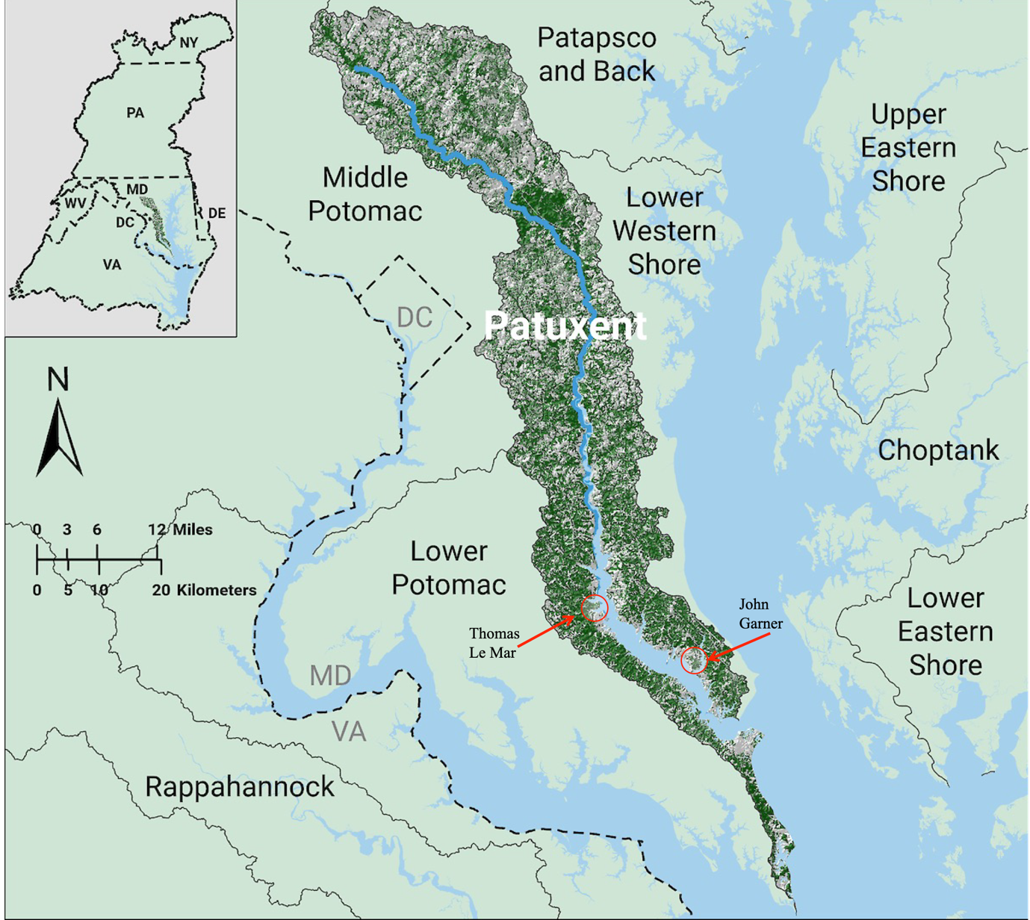

*Figure 1. Map of the Patuxent River showing locations of LaMar and Garner properties in colonial Maryland (St. Mary's and Calvert Counties).*

## 3.2 John Garner of Calvert County (d. 1722)

John Garner's will, probated in 1722, provides important genealogical data:

|  |  |
| --- | --- |
| **Field** | **Value** |
| Name | John Garnor [John Garner] |
| Occupation | Planter |
| Location | Patuxent River, Calvert County, Maryland |
| Will Date | 5 March 1721 |
| Probate Date | 1 September 1722 |
| Wife | Anne (Executrix) |
| Sons | John (d. shortly after without heirs), Robert, Benjamin, Edward, Joseph |

### The Missing Link: William Garner's Mother

William Garner (b. c. 1745) required a mother of the Garner surname. Based on the timeline:

* John Garner of Calvert County died in 1722
* His sons (Edward, Joseph, Benjamin, Robert) would have daughters of childbearing age by the 1740s
* Thomas LaMar (son of John Lamar I) died in 1747
* William Garner was born c. 1745

**Hypothesis:** Thomas LaMar had a relationship with a Garner woman—likely a granddaughter of John Garner of Calvert County—producing William around 1745. The families had known each other along the Patuxent for **three generations** by that point.

# Section 4: Rev. William Garner (c. 1745-1824)

## 4.1 Biographical Summary

Rev. William Garner, Senior was a planter, Revolutionary War Patriot, and pioneering Baptist Minister. He owned property in the Roanoke River Valley along the Virginia-North Carolina border, alternately living between the two states.

|  |  |
| --- | --- |
| **Attribute** | **Details** |
| Birth | c. 1745 (based on first documented appearance and genetic analysis) |
| Death | 1824, Northampton County, North Carolina |
| Occupation | Planter, Anglican Vestry Clerk, Baptist Minister |
| Military Service | Revolutionary War Patriot (provision service, beef driving) |
| Marriage | Lucy Johnston (m. 1780) |
| Residences | Northampton Co., NC; Brunswick Co., VA; Greensville Co., VA |

## 4.2 Key Timeline

|  |  |
| --- | --- |
| **Date** | **Event** |
| 09/24/1765 | First documented appearance: witness to deed in Northampton Co., NC |
| 11/11/1772 | First land purchase: 200 acres along Great Pocosin, Northampton Co. |
| 10/29/1773 | Named as "Clerck of St Johns Chappel" in vestry records |
| 08/22/1774 | Purchased 1070 acres from Sprayberry family, Brunswick Co., VA |
| 10/1773 | Named Clerk of St. John's Chapel, St. George's Parish, Northampton County (Anglican) |
| 03/28/1780 | Married Lucy Johnston (bond posted by William Goodrum) |
| 1780 | Brunswick County public claims: 40 days beef driving service, 6 lbs |
| 1781 | Halifax County NC voucher: "William Garner of Northampton County," 6 lbs sterling |
| 12/27/1787 | Licensed as "Anabaptist Preacher" in Greensville Co., VA (Order Book 1, p. 351); John Cato witness |
| c. 1787 | Became first pastor of Fountain Creek Baptist Church, Brunswick/Greensville Counties |
| 01/07/1791 | Returned marriage of Willis Hall and Mary Camp (Greensville County) |
| May 1792 | Represented Fountain Creek Church at Portsmouth Association meeting |
| 02/1797 | Wrote letter to Isaac Backus from Northampton County (Newton-Andover Theological Seminary) |
| 03/31/1798 | Signed as "W. M. Garner, Pastor and Clerk" of Fountain Creek Church (Randle transfer note) |
| 1805-1807 | Represented Fountain Creek Church at Meherrin Association meetings (August each year) |
| 1824 | Death; will probated December Court 1824 |
|  |  |

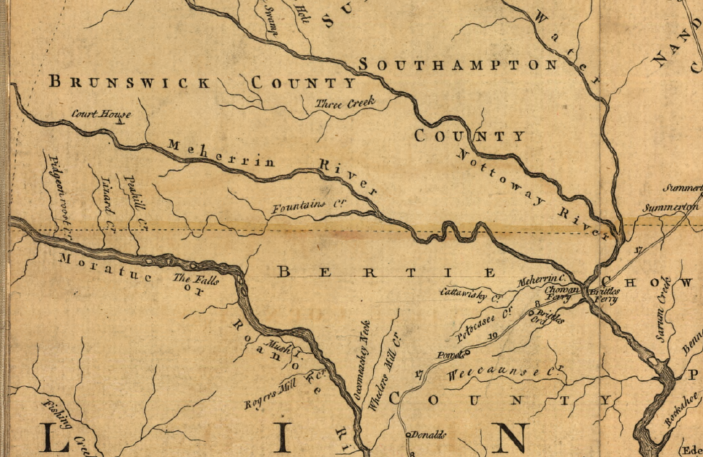

*Figure 2. Excerpt of Jefferson Map (1755) showing Brunswick County, VA and Bertie (later Northampton) County, NC. Dotted line at center is NC/VA border.* (Source: Library of Congress)

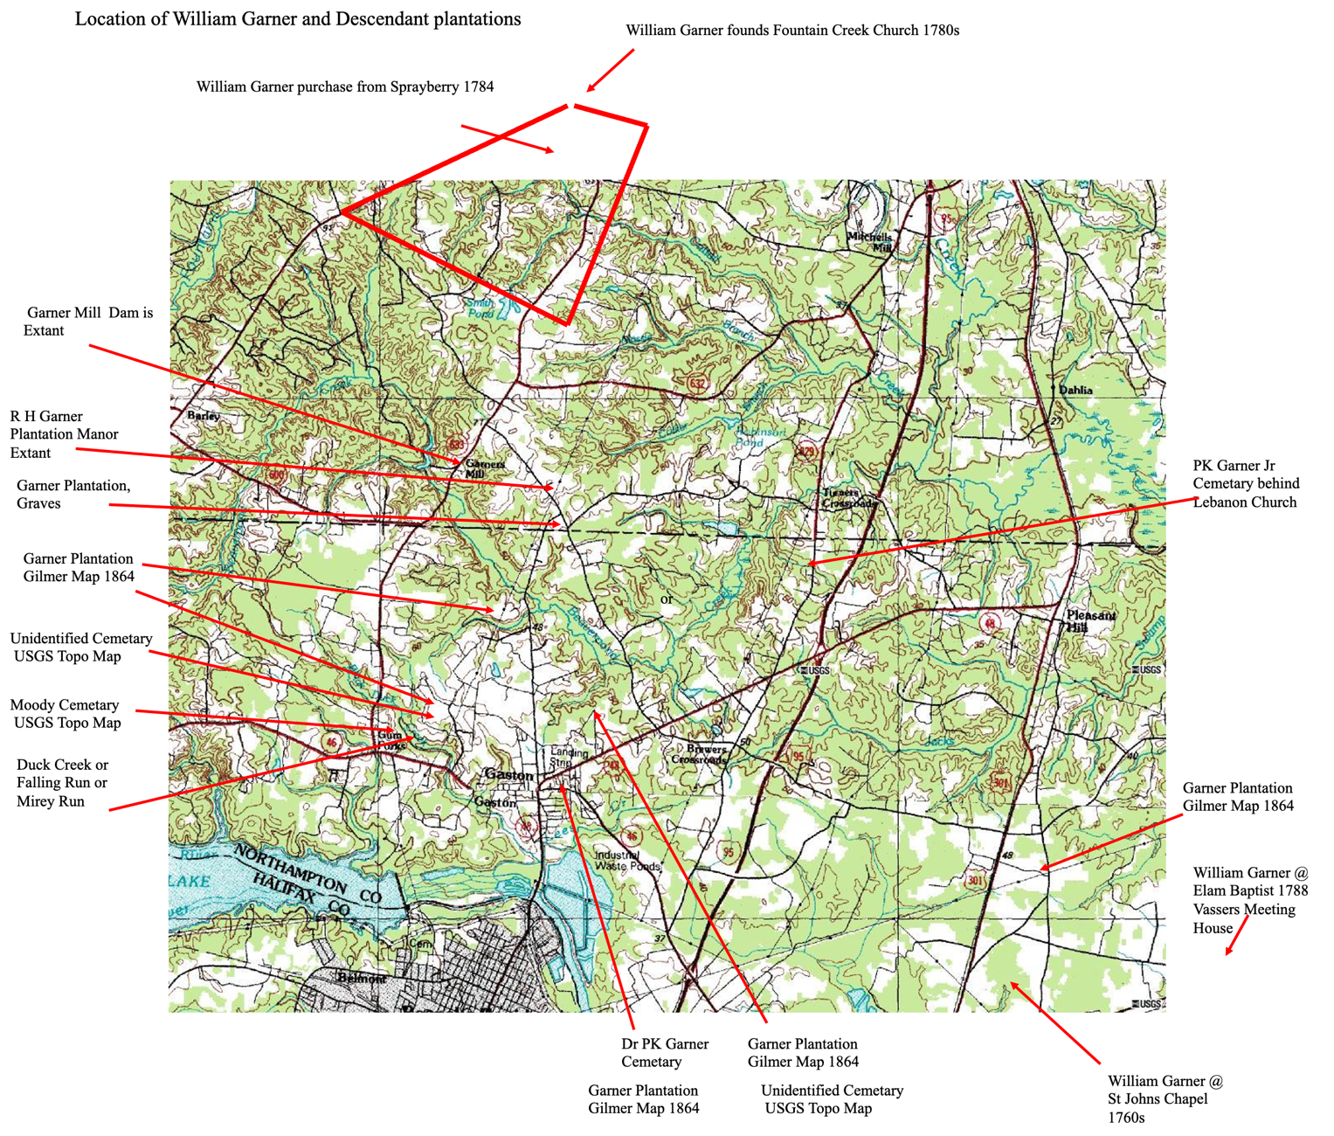*Figure 3. USGS map superimposed with William Garner Sr and Descendant Properties in Brunswick/Greensville County, VA and Northampton County, NC. Dotted line at center is NC/VA border.*

## 4.3 Evidence of Literacy and Social Standing

William Garner's literacy and social achievements are significant for establishing his origins:

* **Signed documents with his signature** (not a mark)
* Served as Anglican Vestry Clerk (required literacy and standing)
* Licensed as Baptist minister
* Accumulated substantial landholdings (over 1,000 acres)
* Owned 22 enslaved persons at death

This profile is consistent with someone whose illegitimate birth was mitigated by quiet support from his biological father's family—the LaMars were substantial planters in Maryland who could have ensured William received an education and start in life.

# Section 5: Revolutionary War Service — Distinguishing Two William Garners

Documentary evidence establishes that **two distinct William Garners** served in the Revolutionary War in the Brunswick/Greensville/Northampton region. Careful geographic and documentary analysis allows us to attribute specific service records to each individual.

## 5.1 The Geographic Distinction

The Meherrin River serves as a critical geographic boundary for distinguishing the two Williams:

|  |  |  |
| --- | --- | --- |
| **Characteristic** | **William Garner (d. 1805 KY)** | **Rev. William Garner (d. 1824)** |
| Residence | NORTH of Meherrin River | SOUTH of Meherrin River, Fountains Creek |
| Primary County | Brunswick/Greensville border region | Northampton Co., NC / Brunswick Co., VA |
| Literacy | Signed with X mark | Signed with signature |
| Known Child | Sally Garner (m. Bennett Goodrum 1781) | John, Samuel, William Jr., daughters |
| Death | 1805, Kentucky | 1824, Northampton Co., NC |

## 5.2 Sally Garner Goodrum's 1849 Deposition

The key document for understanding William Garner (d. 1805 KY)'s military service is the deposition of his daughter, Sally Garner Goodrum, recorded in Warren County, Kentucky in 1849 as part of her husband Bennett Goodrum's Revolutionary War pension application. Sally stated:

*"...he lived in her neighborhood before the war a brother of his name, William Goodrum, who was also a militia soldier and the declarant's father, William Garner, also in said service, all under Capt. Mason..."*

**Critical Point:** Sally explicitly states her father lived "in her neighborhood" before the war. Since Sally married Bennett Goodrum in 1781 and the Goodrums lived **north of the Meherrin River**, her father William Garner also resided in that area—distinct from Rev. William Garner who lived south of the Meherrin at Fountains Creek.

### Service Under Captain James Mason

The militia service under Captain James Mason, including participation in the Battle of Guilford Court House, should be attributed to **William Garner (d. 1805 KY)**—Sally's father—not to Rev. William Garner.

## 5.3 Evidence for Rev. William Garner's Distinct Service

Multiple documentary sources establish that Rev. William Garner (d. 1824) had his own Revolutionary War service, distinct from the other William Garner:

### Halifax County Revolutionary War Voucher (1781)

A Revolutionary War voucher was issued from Halifax County, North Carolina for:

**"William Garner of Northampton County" — 6 Pounds Sterling (1781)**

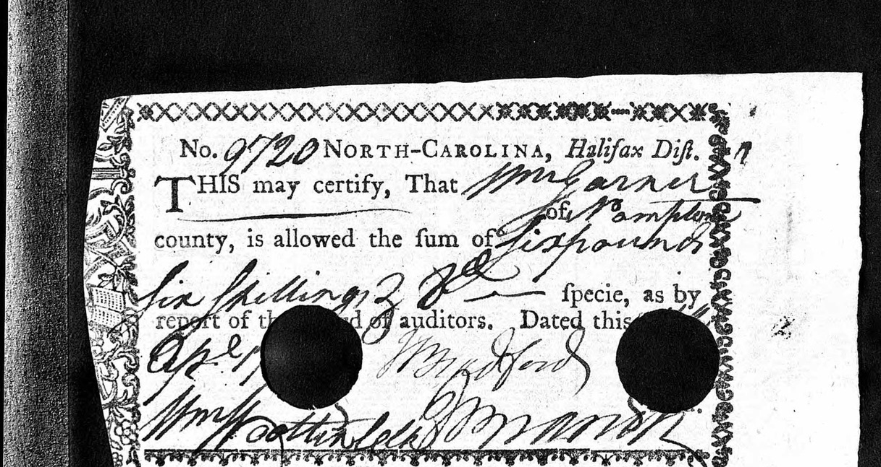

**Geographic Analysis:** This voucher specifically identifies "Northampton County" as William Garner's residence. Halifax County lies immediately across the Roanoke River from Northampton County. Rev. William Garner:

* Owned property in Northampton County (purchased 1772, 1774, 1781)
* Served as Vestry Clerk at St. John's Chapel in Northampton County (1773)
* Was listed on the Northampton Tax List of 1780 with 5,644 pounds in personal property and 422 acres

The *other* William Garner (d 1805, KY; Sally's father) was based north of the Meherrin in the Brunswick/Greensville border region, making him less likely to be identified as "of Northampton County."

### Brunswick County Public Claims (1780)

William Garner is listed in the Brunswick County, Virginia public claims among "persons employed in beef driving," paid **6 pounds** for **40 days** of service in 1780.

**Source:** Court booklet(s): p. 59; Commissioner's book(s): I, p. 113. Public Service Claims, Brunswick County.

**Attribution:** Rev. William Garner purchased 1,070 acres in Brunswick County in August 1774 (the Sprayberry property at Fountains Creek). This substantial landholding would make him a logical candidate for commodity provision to the Revolutionary forces. The beef driving service is consistent with a substantial planter supporting the war effort through supplies rather than militia service.

### Critical Connection: The Matching 6-Pound Value

The identical payment amount of **6 pounds** appearing in both the Brunswick County, VA court record and the Halifax County, NC voucher is almost certainly **not coincidental**. This matching value strongly suggests these two records document **the same service by the same individual**, recorded in two different state systems.

|  |  |  |
| --- | --- | --- |
| **Record** | **Jurisdiction** | **Purpose** |
| Brunswick County VA Court Record: William Garner, 6 lbs, beef driving, 40 days | Virginia | Documentation of the public claim (service rendered) |
| Halifax County NC Voucher: William Garner of Northampton County, 6 lbs sterling | North Carolina | Payment certificate for that service |

### Explanation of Cross-Border Documentation

Rev. William Garner was uniquely positioned as a landholder with substantial property in **both** Brunswick County, Virginia (1,070 acres at Fountains Creek) and Northampton County, North Carolina (multiple tracts). He lived literally on the VA/NC border. Continental Army supply operations did not respect state lines, and a man with property in both states might:

* Perform beef driving service using cattle from his Virginia property
* Have the service documented through Brunswick County, VA courts
* Receive payment through the North Carolina treasury system via Halifax District (which included Northampton County)

**Archival Context:** North Carolina Revolutionary War vouchers that are punched (cancelled) were redeemed through the NC State Treasury. These vouchers eventually returned to the State Treasurer, similar to how cancelled checks return to a bank. A Virginia service record would **not** appear in NC archives—Virginia maintained its own separate treasury system. The presence of this voucher in NC archives, identifying the recipient as "of Northampton County," confirms this was payment to a NC resident through the NC system.

**Significance:** Only Rev. William Garner had substantial property holdings in **both** Brunswick/Greensville County, VA and Northampton County, NC. Only he would logically appear in records of both states for the same service. The *other* William Garner (Sally's father, d. 1805 KY) was based north of the Meherrin in the Brunswick/Greensville VA border area and would not be identified as "of Northampton County" in an NC payment record.

### Greensville County Patriots List

A Revolutionary Patriots plaque at the Greensville County Clerk of Court Archives in Emporia, Virginia lists "William Garner" among those who provided services during the Revolution. The plaque heading states:

*"The Following is a List of the Patriots who rendered services during the Revolution under 'The Commissioners of Provisions Law'. To Lafayette, Baron Von Steuben, General Nelson, General Greene, General Washington and others they gave not only supplies for the Continental Troops, but transported the sick, provisions, and guns."*

**Source:** D.A.R. Magazine, Volume 68, 1934; Virginia State Archives.

**Attribution:** Rev. William Garner's Fountains Creek property was located in the area that became Greensville County (c. 1784). Also listed on this document are families with whom Rev. William Garner closely associated: John Rosser, the Goodrums, the Colliers, and the Brewers.

## 5.4 Summary: Attribution of Service Records

|  |  |  |
| --- | --- | --- |
| **Service Record** | **Location/Amount** | **Most Likely Attribution** |
| Sally Goodrum deposition (Capt. Mason's militia, Battle of Guilford) | "Neighborhood" north of Meherrin | William Garner (d. 1805 KY) |
| Halifax County NC voucher (1781) | "Northampton County" — 6 lbs | Rev. William Garner (d. 1824) |
| Brunswick County VA beef driving (1780) | Brunswick County — 6 lbs, 40 days | Rev. William Garner (d. 1824) |
| Greensville Patriots list | Greensville County | Rev. William Garner (d. 1824) |

**Note:** The matching 6-pound value in both the Brunswick County VA record and Halifax County NC voucher strongly indicates these document the **same service** by Rev. William Garner, recorded in both state systems due to his cross-border property holdings.

## 5.5 Conclusion on Revolutionary War Service

The documentary evidence supports the conclusion that **both** William Garners served in the Revolution, but in **different capacities**:

* **William Garner (d. 1805 KY, Signed with a mark):** Militia service under Captain James Mason, including the Battle of Guilford Court House (per Sally Goodrum's deposition about her father).
* **Rev. William Garner (d. 1824, signature):** Provision and supply service, specifically 40 days of beef driving for 6 pounds, documented in both Brunswick County, VA records and a Halifax County, NC payment voucher.

The matching 6-pound payment in both Virginia and North Carolina records is particularly compelling evidence. This identical amount, appearing in two different state archival systems, demonstrates that Rev. William Garner—as a substantial landholder in **both** states—performed a single service that was documented through Virginia's public claims system and paid through North Carolina's treasury. Only an individual with Rev. William Garner's unique cross-border property holdings would appear in the records of both states for the same service.

# Section 6: The Garner Family Network South of the Meherrin

Additional Y-DNA evidence and documentary research reveals that Rev. William Garner Sr. was part of a coherent **Garner family cluster** operating south of the Meherrin River in Brunswick/Greensville County, Virginia and Northampton County, North Carolina. This network is genetically and socially distinct from William Garner (d. 1805 KY), who lived north of the Meherrin.

## 6.1 The Samuel Garner Y-DNA Confirmation

A descendant of Samuel Garner—whose will was registered in Chatham County but who died intestate in Northampton County, NC—has been Y-DNA tested. The results show a **complete 11-marker Y-DNA match** with the Rev. William Garner Sr. line.

|  |  |
| --- | --- |
| **Finding** | **Implication** |
| Perfect Y-DNA match (11 markers) | William Sr. and Samuel share the same biological father |
| Both carry LaMar Y-DNA | Both are biological descendants of Thomas LaMar (d. 1747) |
| Both used Garner surname | Both took their mother's surname |
| Both owned land south of Meherrin | Same family group, same community |
| Both signed Greensville partition petition | Active in same civic network |

**Conclusion:** William Garner Sr. and Samuel Garner were likely **brothers**—either full brothers (same mother and father) or half-brothers (same father, Thomas LaMar, but potentially different Garner mothers). This confirms that Thomas LaMar fathered **multiple children** who carried the Garner surname.

## 6.2 The "South of Meherrin" Garner Clan

Documentary evidence reveals a coherent Garner family cluster operating south of the Meherrin River, distinct from other Garners in the region:

|  |  |  |  |
| --- | --- | --- | --- |
| **Individual** | **Dates** | **Key Characteristics** | **Y-DNA Status** |
| Rev. William Garner Sr. | c.1745-1824 | Signed with signature, Baptist minister, major landholder, Vestry Clerk | LaMar (confirmed) |
| Samuel Garner | d. Northampton Co. | Landholder below Meherrin, will registered Chatham Co., signed partition petition | LaMar (confirmed) |
| Presley Garner | 1757-1837 | No land in VA, witnessed Samuel's deed, signed partition petition, relocated to SC | Likely same group |

This group is **distinct from** William Garner (d. 1805 KY) who lived **north** of the Meherrin River, signed documents with an X mark (Figure 4), and was Sally Goodrum's father.

## 6.3 Presley Garner (1757-1837): Family Connections

Presley Garner provides important evidence of family relationships within the "South of Meherrin" Garner network:

### Biographical Summary

Presley Garner (10/26/1757-7/10/1837) was born in the Brunswick County region and served as a seaman on the Virginia sloop of war "Tempest" during the Revolutionary War. He witnessed Samuel Garner's sale of land to Brewer and signed the 1787 petition to partition Greensville County from Brunswick. After the Revolution, he relocated to Richland County, South Carolina, where he established Garner's Ferry on the Wateree River and accumulated over 4,000 acres of land.

### Evidence of Family Relationship

* **Witnessed Samuel Garner's deed:** Presley appeared as a witness to Samuel Garner's sale of land to Brewer, indicating close association
* **Signed partition petition:** Both Presley and Samuel Garner signed the 1787 petition to create Greensville County
* **Brought "nephews" to SC:** Presley brought Edmund L. Garner and Thomas L. Garner (described as nephews) to South Carolina as overseer and heir
* **Naming pattern:** Rev. William Garner Sr.'s grandson was named Dr. Presley Killingsworth Garner (buried in Gaston, Northampton Co., NC), honoring the family connection

### Birth Date Analysis

Presley Garner's tombstone provides precise birth data: "Aged 80 years, 8 months and 14 days" at death on July 10, 1837, yielding a birth date of October 26, 1757. This creates an important chronological consideration:

* Thomas LaMar died in 1747
* Presley Garner was born in 1757 (10 years after Thomas's death)
* Therefore, Thomas LaMar could not have been Presley's biological father

**Hypothesis:** Presley was likely (1) a half-brother through the Garner mother's later relationship, (2) a cousin through another Garner/LaMar union, or (3) unrelated biologically but socially integrated into the clan through proximity and shared community. The recycling of the name "Presley" in Rev. William Garner Sr.'s line (grandson Dr. Presley Killingsworth Garner) strongly suggests acknowledged family connection.

## 6.4 Rev. William Garner's Religious Ministry (1773-1824)

William Garner was a dedicated religious man whose name appears in pre-Revolution Anglican records and in Baptist Church records, suggesting that he served the faithful for **over 50 years** prior to his death in 1824.

### Anglican Service: Clerk of St. John's Chapel (1773)

In 1758 Northampton County was divided into two parishes. The Vestry records of St. George's Parish are rich in early Northampton County history. In **October 1773**, William Garner was named as the **Clerk of St. John's Chapel**. The Clerk carried significant responsibilities:

*"Where a minister was resident in the parish it was customary for him to hold regular services of Morning and Evening Prayer at the parish church on Sundays... These daily offices were read by the minister at the chapels on week-days and occasionally on Sundays, but generally they were read by the chapel clerk on Sundays. The sermon was an important part of the Sunday services, and was seldom dispensed with. In the absence of the minister, the clerk usually read a homily approved for such use. The Prayer Book was strictly adhered to, and there was no Hymn Book as we know it today. Instead, the Psalter was sung or said under the clerk's leadership."*

Meetings of the St. George vestry stopped abruptly on October 16, 1776 as the Revolution disrupted Colonial society. The collapse of the Anglican Church as an extension of Crown rule resulted in increased opportunity for small congregations to control how they worshipped. Former Anglicans began to gravitate to other denominations, and William Garner was drawn to the Baptists.

### Baptist Ministry License (1787)

At December Court in Greensville County VA, William Garner was granted license as **"an Anabaptist Preacher is permitted to perform rites of matrimony"** on 12/27/1787 with John Cato as witness (Greensville County Order Book 1, 1781-1789, p. 351).

### Burkitt and Read: Contemporary Eyewitness Source

The primary source for William Garner's Baptist ministry is *A Concise History of the Kehukee Baptist Association* (1803; revised 1850) by **Elder Lemuel Burkitt** and Elder Jesse Read. Significantly, Burkitt was not writing distant history—he was **a contemporary of William Garner** who knew him personally:

* Burkitt (1750-1807) was pastor of Sandy Run Baptist Church in Bertie County from 1773-1807
* Burkitt served as Clerk of the Kehukee Association for 29 years
* **Burkitt was a Northampton County native**—his grave and historical marker are near Rich Square, just a few miles from William Garner's plantations near Gaston
* Burkitt was a delegate at the Constitutional conventions at Hillsboro (1788) and Fayetteville (1789), advocating for separation of church and state—the same cause William Garner supported

In their preface, Burkitt and Read state: *"the greatest part of the History, our readers may depend on the reality of those facts recorded, as we were both eye and ear witnesses to them."* This establishes their account of William Garner's ministry as eyewitness testimony, not secondhand tradition.

### Fountain Creek Baptist Church: First Pastor

The primary account of William Garner's pastoral ministry appears in Burkitt and Read's history (1803), pages 282-283, under the heading *"THE CHURCH ON FOUNTAIN'S-CREEK, GREENSVILLE COUNTY":*

*"Some of the members who at first composed this church were baptized by Elder Zachariah Thompson, and were under his care for several years; and about this time there was a considerable revival of religion in these parts. After some time, a church was constituted here, and* ***Elder William Garner took the pastoral care of the same****; and became a member of the Kehukee Association, and continued so until the division took place between the Kehukee and the Virginia Portsmouth Associations, and then, of course, this church became a member of the Portsmouth Association, because she fell within the boundaries of the same. This church, like others, has experienced her different seasons; both of declensions and revivals. For some years past, religion seemed cold; but of late, a considerable revival has taken place. We learn that in this late revival, several of the Methodist Society have submitted to the ordinance of baptism.* ***There is a branch of this church in Northampton county, North Carolina. The congregation assembles at a meeting-house, called Vasser's meeting-house, about ten miles above Northampton court-house.*** *The church on Fountain's-Creek was constituted about the year 1787."*

This passage establishes several crucial facts:

* **Elder William Garner "took the pastoral care"** of Fountain Creek Church—confirming his role as first pastor
* The church was **"constituted about the year 1787"**
* Members were first baptized by **Elder Zachariah Thompson** of Brunswick County, Virginia
* The church had an **"arm" or branch in Northampton County, NC** at **Vasser's Meeting House**, "about ten miles above Northampton court-house"
* The church transferred from **Kehukee Association to Portsmouth Association** when the Virginia churches separated (1790)
* By 1803, "a considerable revival has taken place" with "several of the Methodist Society" submitting to Baptist baptism

**Note on Source:** The researcher possesses a personal copy of the rare Halifax, NC printing of this book from 1803—the original edition published during William Garner's lifetime (d. 1824).

The research of William Simpson at the Virginia Baptist Historical Society has further corroborated William Garner's role at Fountain Creek Church, consistent with the Burkitt and Read passage quoted above.

Additional details from later sources describe the church's physical structure: The first place of worship was a one-room frame structure which had a **gallery for slaves** who were accepted as members.

Burkitt and Read's reference to Vasser's Meeting House "about ten miles above Northampton court-house" corresponds to the present-day community of **Gaston, NC**. This "arm" of Fountain Creek Church later became **Elam Baptist Church** (organized 1844), presently located near Gumberry, North Carolina, in Northampton County.

**Geographic significance:** On the Gilmer Map of Greensville and Northampton Counties (1864), a Garner plantation was located about half a mile north from Elam Church in Gumberry. William Garner's easternmost plantations in Northampton County were located within a mile of Vasser's Meeting Place (now Gaston). His Brunswick/Greensville property was immediately adjacent to the location of the present-day site of **Fountain Creek Baptist Church (8099 Brink Road, Emporia, VA 23847)**.

### Baptist Association Involvement

Rev. William Garner participated in at least three Baptist associations:

**Kehukee Association (organized 1769):** Active 1786-1791. No minutes extant for years during which William was active.

**Portsmouth Association (organized 1791):**

|  |  |
| --- | --- |
| **Year** | **Record** |
| May 1791 | Fountain Creek Church, Brunswick County, supposed to be represented by William Garner, but he was not present |
| May 1792 | Fountain Creek Church, Brunswick County, was represented by William Garner |
| May 1793-1794 | Fountain Creek Church, supposed to be represented by William Garner, but he was not present |
| May 1796 | Fountain Creek Church, now in Greensville County, supposed to be represented by William Garner, but not present |
| May 1797-1799 | Fountain Creek Church, supposed to be represented by William Garner, but he was not present |
| May 1800-1804 | Church had other representatives or no representatives |

**Note:** Sometime between 1794-1796, the area of Brunswick County in which Fountain Creek was located was incorporated into Greensville County.

**Meherrin Association (organized 1804):**

* **August 1805:** Represented Fountain Creek Church
* **August 1806:** Represented Fountain Creek Church
* **August 1807:** Represented Fountain Creek Church
* 1808-1815: Church had other representatives or no representatives

### Marriage Returns by Rev. William Garner

Willis Hall married Mary Camp, daughter of Sally Camp. Sureties were supplied by Edward Delbridge. Witnessed by S. Hall and John Hall and **returned by Rev. William Garner January 7, 1791** (*Marriages of Greensville County Virginia and Ministers Returns 1781-1825*, by Catharine Knorr, p. 21).

**March 31, 1798:** When James and Roseanna Graves Randle joined Powelton Baptist Church in Hancock Co, GA, they had a note of introduction signed by "W. Avery and W. M. Garner, Pastor and Clerk of Fountain Creek Church in Greensville Co, VA" (Personal Communication, Lewie Dunn).

### The 1797 Letter to Isaac Backus

In 1797, Elder William Brame of Richmond traveled to the homes of several Baptist ministers in the Roanoke Valley region. At his request several ministers began correspondences with Isaac Backus, the famous New England Baptist leader and church historian. Elder Brame personally delivered letters to Rev. Backus as he traveled between the South and New England.

In the Isaac Backus collection at Newton-Andover Theological Seminary (Harvard University affiliate, School of Religion) are three letters from Kehukee ministers: **William Garner, Thomas Gardner, and Lemuel Burkitt**. The full text of William Garner's letter:

*"Northampton County North Carolina*

*Our Worthy Brother Wm Brame came to my House last Evening & in our Discourse he Informed me that he was acquainted with a Preacher Named Isaac Backus my calling to mind the Reading of a Piece of yours setting forth some years past caused me to crave the happiness of seeing your face in time but thinking of the distance being so great and the many years [tha]t we have both seen cannot expect it, therefore have made bold to Write to you tho a stranger; Dear Brother some years Past the Candle of the Lord seemed to Shine among us, Sinners were Crying for Mercy & Saints Rejoicing in the Lord but our Present state seems to be much to the Reverse, many have lately Departed from the Faith & is to be feared given heed to Seducing Spirits, Iniquity abounding & the love of many Waxing Cold, which causes me many times to complain of my bareness, &makes me often crave the Prayers of all them that know the truth, If we cannot have your Personal Prescence we hope to be Remembered in Prayer, so end with a sincere desire that that the Lord may add many souls to your Ministry & your last days may be your best days*

*(Turn Over)*

*I have been Long time thinking of that Day of the Prophet that the Knowledge of the Lord shall cover the Earth as Water do the Sea but see so little Prospect of its begin to be out of Heart of ever seeing such a Glorious time Militant*

*So no more at Present only beg leave to Subscribe myself you Loving and well wishing Brother till Death*

*N.B. Plese to give Respects to Your Wife & Family"*

[Notation added in different ink by Isaac Backus]: **"Answered July 10, 1797"**

### Historical Context: Baptists and Religious Liberty

The Baptists were deeply involved in the fight for separation of Church and State. The basis for separation was driven by a need for protection from the influence of the Government on religious freedom. In Colonial times, violence and incarceration was common for Baptist ministers. Elder Leland wrote that in Virginia between 1768 and 1775, "about thirty preachers were honored with a dungeon."

In 1785, Elder Leland and leaders of the Kehukee Association had member congregations form petitions against a bill known as "the bill establishing a provision for the teachers of the Christian Religion" in the Virginia Legislature, which would compel every person to pay a tax for the support of some teacher of the Christian religion. These petitions were collected and presented to the General Assembly and the bill was ultimately defeated.

Reverend Lemuel Burkitt, the organizer and driving force of the Kehukee Association, was raised in Northampton County. He was chosen as a representative of Hertford County at the Constitutional conventions at Hillsboro (July 21, 1788) and Fayetteville (November 21, 1789), where he pointed out the dangers that may follow if the Constitution and Bill of Rights lacked protection of religious freedom via separation of church and state.

### Signature Comparison

The signature on the 1797 letter has been compared with the signature on the 1818 Tucker Petition (a land valuation document signed 21 years later). The signatures show consistent handwriting characteristics, confirming both documents were signed by the same individual—Rev. William Garner Sr. of Northampton County (Figure 4).

On the 1818 Tucker Petition, William Garner signed alongside "Caden Mitchell" and "John Garner" (likely his son), demonstrating his continued civic engagement at approximately age 73.

## 6.5 Revised Understanding: The Garner-LaMar Family Network

|  |  |  |
| --- | --- | --- |
| **Category** | **Members** | **Evidence** |
| Confirmed LaMar biological sons | Rev. William Garner Sr., Samuel Garner | Y-DNA match, Thomas LaMar's will |
| Probable family members | Presley Garner (1757-1837) | Social network, witnessed deeds, naming patterns |
| South Carolina Branch | Presley Garner, Edmund L. Garner, Thomas L. Garner | Migration to Richland Co., Garner's Ferry |
| North Carolina Branch | Rev. William Garner Sr.'s descendants, Dr. Presley Killingsworth Garner | Remained in Northampton/Gaston area |
| Distinct/Unrelated | William Garner (d. 1805 KY) | North of Meherrin, signed with X, different network |

## FIGURE 4. Signiture of William Garner of Brunswick/Greensville and Northampton county 1818 and 1797

## Figure 5. Mark of William Garner ( d1805, KY) who witnessed a Brunswick county deed in 1756

## 6.6 Significance of the Expanded Family Network

The identification of multiple LaMar biological sons carrying the Garner surname has significant implications:

1. **Multiple illegitimate children:** Thomas LaMar (d. 1747) fathered at least two children (William and Samuel) who took the Garner surname, suggesting either a sustained relationship with a Garner woman or relationships with multiple Garner women.
2. **Coherent family unit:** Despite illegitimate origins, William, Samuel, and Presley Garner functioned as a recognizable family unit—witnessing each other's deeds, signing petitions together, and maintaining naming traditions.
3. **Geographic clustering:** All three resided south of the Meherrin River in the Brunswick/Greensville/Northampton border region, while the unrelated William Garner (d. 1805 KY) lived north of the Meherrin.
4. **Migration patterns:** Presley Garner's relocation to South Carolina, bringing "nephews" Edmund L. and Thomas L. Garner, suggests ongoing family cohesion across state lines.
5. **Naming traditions:** The naming of Rev. William Garner Sr.'s grandson as "Dr. Presley Killingsworth Garner" demonstrates honored family connections across generations.

## 6.7 The Killingsworth Connection

The "Killingsworth" middle name borne by Dr. Presley Killingsworth Garner (1835-1861) indicates a family alliance that can be traced through genealogical records. The Killingsworth family registry reveals connections to both the Garner and LaMar spheres of influence:

### Killingsworth Family Origins

The Killingsworth family originated in **Surry County, Virginia**—the same general region as early Garner settlement. William Killingsworth I (c.1658-1709) held 60 acres in Surry County, and his descendants migrated southward through Edgecombe County, NC to South Carolina, following the same migration corridor as the Garner clan.

### The Garner-Killingsworth Marriage

The Killingsworth registry records that **Mary Polly Killingsworth** (b. 1758 in South Carolina), daughter of William Killingsworth IV, married **"Grideon GARNERM"** (likely Gideon Garner, with the surname misspelled). This Gideon Garner is almost certainly the **Gideon Garner** named as a son in Samuel Garner's 1809 will.

### South Carolina Convergence

The Killingsworth and Garner families converged in Richland County, South Carolina:

* **Jacob Killingsworth (1745-1798)** died in Richland County, SC
* **Presley Garner (1757-1837)** established Garner's Ferry in Richland County, SC by 1790
* Both families were present in the same county during the same period

**Conclusion:** The "Killingsworth" middle name in Dr. Presley Killingsworth Garner reflects an honored family alliance, likely through the marriage of Gideon Garner (Samuel's son) to Mary Polly Killingsworth. This naming pattern—combining "Presley" (honoring Presley Garner) with "Killingsworth" (honoring the Killingsworth alliance)—demonstrates the interconnected nature of the "South of Meherrin" family network.

## 6.8 Samuel Garner's 1809 Will

Samuel Garner's 1809 will (Chatham County Will Book B, p. 130) provides critical documentation of his family and confirms his connection to the broader Garner network:

### Will Summary

**Testator:** "Samuel Garner, of the County aforesaid [Chatham], being of sound disposing mind and memory"

**Wife:** Sally Garner ("my lovely wife Sally Garner")

**Children by present wife Sally:** Gilbert, Gideon, Samuel (sons); Jinsey, Mildred (Milley), Elizabeth (daughters)

**Older children (first wife Milley):** Guilford, Jemima Cobb, Juda Stark, Polly Garner

**Executors:** "my beloved son Guilford Garner and my son in Law **William Garner**"

**Enslaved persons named:** Hannah, Sary, Roda, Daniel, Tabby, Edd, Decy, Winnie, Archie

### Key Evidence

* **"Son-in-Law William Garner" as executor:** This is likely William Garner Jr., son of Rev. William Garner Sr., confirming the close relationship between the two families.
* **Gideon Garner named as son:** This is the "Grideon GARNERM" who married Mary Polly Killingsworth, explaining the Killingsworth connection.
* **Two wives documented:** First wife "Milley" (Mildred), then "Sally." The 1785 marriage record confirms: "William Collier marries Judy Garner daughter of Samuel Garner and Milley Garner."

### The 1785 Judy Garner Marriage Record

A key record from *Marriage Bonds and Minister's Returns of Greensville County, VA 1781-1825* (Knorr, 1955):

*"William Collier marries Judy Garner daughter of Samuel Garner and Milley Garner. Surety Thomas Garner. Witnessed by William and John Garner."*

This 1785 record demonstrates that **Rev. William Garner Sr. and his son John witnessed the marriage of Samuel Garner's daughter**—providing direct documentary evidence of the close relationship between Rev. William Garner Sr. and Samuel Garner, consistent with them being brothers.

## 6.9 Documentary Database Evidence

A comprehensive database of Garner family deeds, wills, and court records from Brunswick, Greensville, and Northampton counties provides statistical confirmation of family relationships through patterns of joint activity:

### Joint Activities: Rev. William Garner Sr. and Samuel Garner

The database records **9 separate occasions** between 1778 and 1800 where both William and Samuel Garner appear together in legal documents:

|  |  |
| --- | --- |
| **Date** | **Joint Activity** |
| July 18, 1778 | Both witnessed deed from Burrell Lucy to Robert Horton |
| July 29, 1778 | Both witnessed deed from Burrell Lucy to Robert Horton (Great Pocosin) |
| Jan 13, 1780 | Both witnessed deed from Peter Ware to George Brewer |
| Oct 23, 1782 | Both witnessed deed of gift from Elisabeth Jones to children |
| Sept 16, 1785 | Both purchased from estate of Lemuel Lockhart |
| Oct 31, 1794 | Samuel and John Garner witnessed William's land grant survey |
| Sept 16, 1798 | Both purchased from Also Collier |
| Jan 17, 1800 | Both purchased from Anne Norwood |

This pattern of **repeated joint activities over 22+ years** strongly supports the conclusion that William Sr. and Samuel were brothers rather than merely neighbors. Unrelated neighbors would not consistently appear together as witnesses and co-purchasers across multiple decades.

### The 1788 Brunswick County Tax List

The 1788 Brunswick County tax list shows all four "South of Meherrin" Garners taxed together:

|  |  |  |
| --- | --- | --- |
| **Name** | **Enslaved Persons** | **Notes** |
| William Garner | 2 | Rev. William Garner Sr. |
| Samuel Garner | 15 | Wealthiest Garner |
| John Garner | 2 | Likely son of William Sr. |
| Presley Garner | 6 | Family associate |

### Two William Garners: Marriage Record Proof

The database definitively confirms two distinct William Garners through marriage records:

|  |  |  |  |
| --- | --- | --- | --- |
| **Year** | **Groom** | **Bride** | **Identity** |
| 1780 | William Garner | Lucy Johnston | Rev. William Sr. |
| 1786 | William Garner | Mary Samford | Other William |

Since Rev. William Garner Sr. married Lucy Johnston in 1780, the William Garner who married Mary Samford in 1786 must be a **different individual**.

### The William Garner Who Relocated to Surry County, NC

The William Garner who married Mary Samford can be traced relocating to Surry County, North Carolina with his Samford in-laws:

|  |  |
| --- | --- |
| **Date** | **Event** |
| 3/26/1786 | William Garner marries Mary Samford; bond posted by William Samford (Brunswick) |
| 1/28/1793 | William Garner grants Power of Attorney to John Haggard of Surry County, NC — listed alongside William Keen Samford, Joseph Samford, James Samford (Brunswick Deed Book 15, p. 354) |
| 2/23/1795 | William Garner (with wife Mary) sells property to Joseph Samford (Brunswick Order Book 16, Part 2, p. 353) |
| After 1795 | William Garner died in Surry County, NC |

**Possible identification:** This William Garner may be the "son in Law William Garner" named as co-executor in Samuel Garner's 1809 will (Chatham County). The will was **unprobated**, possibly because one of the named executors was deceased or unavailable. The exact relationship between this William Garner and Samuel Garner requires further research.

### Rev. William Garner Sr.: Continuous Presence in Northampton/Greensville

In contrast to the William Garner who relocated to Surry County, Rev. William Garner Sr. maintained continuous presence in the Northampton/Greensville area:

* **1773:** The vestrymen on St George’s Parish, Northampton County “ordered that William Gar(d)ner be continued Clerck and Henry Clark Sexton of Saint Johns Chappel at their usual salarys” (Northampton)
* **1787:** Founded Fountain Creek Baptist Church (Brunswick)
* **1787:** Licensed as "Anabaptist Preacher" (Greensville)
* **1790:** Returned marriage of Willis Hall and Mary Camp (Greensville)
* **1794:** Land grants on Falling Run (Northampton)
* **1815-1818:** Records identify him as "William Garner Sr" (Northampton)
* **1822:** Writes will naming sons John, Samuel, William Jr. (Northampton)
* **1824:** Will probated (Northampton)

This continuous documentary presence in Northampton/Greensville from 1780-1824 confirms that Rev. William Garner Sr. **never relocated to Surry County**, distinguishing him from the William Garner who married Mary Samford and moved with the Samford family.

### The Surry County, NC Garner Branch

Census records reveal a distinct Garner family cluster in Surry County, North Carolina, separate from Rev. William Garner Sr.'s line in Northampton/Greensville:

|  |  |
| --- | --- |
| **Year** | **Garners in Surry County, NC Census** |
| 1790 | John Garner, William Gardner, Wyatt Garner |
| 1800 | John Garner, William Gardner, Jacob Gardner |

The 1790 appearance of William, John, and Wyatt Garner in Surry County NC—just three years before William Garner (husband of Mary Samford) granted Power of Attorney to John Haggard **of Surry County, NC**—confirms the relocation of this Garner group to Surry County with the Samford family.

### Wyatt Garner's Return to Northampton County

By the 1840s-1850s, a Wyatt Garner appears in Northampton County deed and census records, suggesting a return migration to ancestral territory. The 1850 Northampton County Census shows:

|  |  |  |  |  |
| --- | --- | --- | --- | --- |
| **Name** | **Age** | **Sex** | **Occupation** | **Birthplace** |
| Wyatt Garner | 25 | M | Farmer | NC |
| Elizabeth Garner | 30 | F |  | NC |
| Martha A. Garner | 4 | F |  | NC |
| Lucy E. Garner | 3 | F |  | NC |
| Mary J. Garner | 2 | F |  | NC |
| William J. Garner | ½ | M |  | NC |
| Mary Garner | 15 | F |  | NC |

**Significance of naming pattern:** Wyatt Garner's daughter **"Lucy E. Garner"** (age 3 in 1850) echoes the name of Rev. William Garner Sr.'s wife **Lucy Johnston**. This suggests possible family memory connecting the Surry County branch back to the original Garner family in Northampton/Brunswick, even if the exact relationship remains to be documented.

The Northampton County deed index shows Wyatt Garner active in land transactions from the 1840s:

* **3/8/1850:** Wyatt Garner purchased from T.J. Garner (Bk 33 Pg 315)
* **11/18/1868:** Wyatt Garner purchased from Jno Morgan (Bk 38 Pg 616)

The 1850 purchase from **T.J. Garner (Thomas J. Garner)**—grandson of Rev. William Garner Sr.—indicates interaction between the Surry County branch and the main Northampton Garner line, though the exact family relationship requires further research.

## 6.10 Samuel Garner (Son of Rev. William Sr.) and the Turner Connection

**Important clarification:** There were **two different Samuel Garners** in the family:

|  |  |  |
| --- | --- | --- |
| **Individual** | **Relationship** | **Location/Evidence** |
| Samuel Garner (d. after 1809) | Brother of Rev. William Sr. | Chatham County; 1809 will; wife Sally |
| Samuel Garner (d. after 1841) | Son of Rev. William Sr. | Northampton County; sons Thomas & Bradford |

### The 1835 Grand Jury Presentment

Court records from Northampton County (CR071.326.15 Court of Pleas and Quarter Records 1834-1836) document a presentment against Samuel Garner (son of Rev. William Sr.):

**September Term 1835:** "The jurors for the State upon their oath present that **Samuel Garner and Winney Turner** both late of the County of Northampton... did and still do bed and cohabit together committing the crime of fornication and adultery — the said Winney Turner having taken the said Samuel Garner into her house... the said Winney Turner & the said Samuel Garner while living together in a state of lewdness, fornication & adultery **had a child or children born unto them**."

Samuel was also presented for "trading with Negroes for Cotton."

### Winney Turner: "Portuguese" (Triracial Isolate)

Winney Turner was described as **"Portuguese"** — a designation commonly applied to **triracial isolate communities** in the Gaston, NC region. These communities, possibly descended from Fort Christina Indians, were classified separately from both white and Black populations. Similar communities include the Melungeons, Lumbee, and other mixed-ancestry groups throughout the Southeast.

### Y-DNA Match with Turner Descendants

**Critical genetic evidence:** Y-DNA testing has confirmed matches between Garner descendants and **Turner descendants** from this union. This proves:

* Samuel Garner fathered children with Winney Turner
* These children took the **Turner surname** but carry **LaMar Y-DNA**
* This represents **another instance** of LaMar Y-DNA passing through non-marital union to a different surname line

**Pattern recognition:** The Samuel Garner–Winney Turner relationship mirrors the original LaMar-Garner connection: illegitimate children taking their mother's surname while carrying the father's Y-DNA. The LaMar Y-DNA has now been documented passing to at least three surname lines: **Garner/Gardner** (from the original LaMar connection), and now **Turner** (from Samuel Garner's relationship with Winney Turner).

### Samuel Garner's Sons: Thomas and Bradford Garner

The court records also document Samuel's legitimate sons:

* **Thomas Garner (d. 1837)** — mentioned as brother of Bradford in Thomas's will (Northampton WB 4/160); referenced landmarks of William's property; married Nancy; died within a month of writing will, without issue
* **Bradford Garner (d. after 1860)** — December 1835: charged with assault and battery; Thomas Garner was a material witness; married Milley Sexton; moved to Halifax County, NC

December 1835 Grand Jury presentment: "Mason Garner, Thos Garner, Benj High, & Bradford Garner... Assault & Battery in the Month October Last at William A Moody."

### Thomas Garner's Will (1837)

Thomas Garner's will (Northampton County Will book WB-4/160, September Court 1837) confirms his relationship to Bradford:

**Item 1st:** "It is my will and desire that **my brother Bradford Garner** shall have my half of [property]..."

Thomas died within a month of writing this will, leaving his wife Nancy and his estate to his brother Bradford.

### Bradford Garner's Family and Civil War Legacy

Bradford Garner married Milley and had at least three sons who enlisted in the Confederate Army during the Civil War:

* **Albert W. Garner**
* **John Garner**
* **James Henry Garner** (c.1845-?) — Private, Co. C, 32nd NC Infantry; surrendered at Appomattox April 9, 1865; moved to Halifax County ~1867

Bradford sold land to his father Samuel (1838 deed) and appears in the 1840 and 1850 census records. Bradford and Milley were still living at the time of the 1860 census. James Henry Garner (Bradford's son) is the **great-great-grandfather of the researcher C. Edwin Garner**.

## 6.11 Richard H. Garner: Sheriff and NC Representative

**Richard H. Garner** (son of John Garner, grandson of Rev. William Garner Sr.) achieved significant prominence:

* **Sheriff of Northampton County**
* **North Carolina State Representative**
* Home located just across NC/VA line in Greensville County, on the road to Brunswick County Court House
* House situated north of Beaverdam Creek on Spring Church Road
* **"Richard Garner's gate"** — referenced as a landmark in deeds, marking the border between NC and VA

The Richard H. Garner house site on Spring Church Road includes an **extant graveyard with "Ancient Garner Graves"**. This location is just north of the crossing of Beaverdam Creek and adjacent to William Garner Sr.'s northeasternmost Northampton property on the Gaston Road. Richard H. Garner's descendants continued to live on this border property into the 20th century.

Richard H. Garner appears in multiple estate records as administrator, including the 1850 administration bond for Gilford Garner's estate (witnessed by R.H. Garner, John M. Moody, and James Garner) and sworn testimony regarding land divisions.

## 6.12 Dr. Presley K. Garner and the Greensville/Gaston Garners

An interview conducted July 13, 2002 with **Presley Killingsworth Bradley** (born September 7, 1927), a descendant of Susan Garner Bradley, provides valuable oral history about the Garner family in the Greensville/Gaston area.

### Dr. Presley K. Garner Sr. Burial Site

Dr. Presley K. Garner Sr. (1835-1861) is buried near the old water tower (still standing) in Gaston, NC. He was initially buried in a **cast iron vault above the ground** with his gold watch displayed under a glass cover. Within weeks of his burial, thieves broke the glass and stole the watch. Alonza Woodruff and Percy Lundy Bradley built a cement cover over the vault for protection. In the 1950s, vandals opened the vault and removed the casket; Presley K. Bradley replaced the casket and re-closed it.

The cemetery can be accessed from Roanoke Rapids via Hwy 48 to Gaston; at the intersection of Hwy 48 and 46, turn right, go about 1/4 mile and turn left toward the water tower. At least 3 additional marble stones are present besides Dr. P.K. Garner's grave.

### Presley K. Garner Jr.

Presley K. Garner Jr. lived near Garysburg, next to Lebanon Church. Physical description: 6' tall, slightly stout, blue eyes, goatee and moustache, dressed in khakis shirt and suspenders.

He married twice: (1) **Hattie Claibourne Powell**, and (2) Ms. Sannah/Susannah (no issue). Children by first wife:

* **Susan Ann Garner** (December 1, 1890 – December 8, 1984) — married Percy Lundy Bradley, December 24, 1912
* Laura Garner (m. Leonard Woodruff)
* Hattie Garner (m. Martin Norwood) — died in childbirth
* Unknown son (died age 13-14 in horse accident)

P.K. Garner Jr. and his second wife Zanna are buried on land that once belonged to P.K., just east of Gaston on Lebanon Church Road.

### Susan Ann Garner Bradley (1890-1984)

Susan Ann Garner had dark red hair and brown eyes. She was well schooled and played the piano and organ in church. She married **Percy Lundy Bradley** (November 20, 1883 – February 1953), a blacksmith of great skill who owned the 3rd car in Roanoke Rapids. They lived in Barley, Greensville County, VA.

Susan and Percy Bradley had 8 children (all with dark auburn/red hair):

* Marvin Garner Bradley (April 5, 1914 – June 16, 1983)
* Percy Louise Bradley (October 3, 1916)
* Lottie Lucille Bradley (January 28, 1922)
* Willie Benjamin Bradley (March 1, 1924)
* **Presley Killingsworth Bradley** (September 7, 1927) — the interviewee; married Mildred Floyd Webb
* Dalton Elisha Bradley (February 8, 1930)
* Charles Gee Bradley (January 12, 1932)
* Hattie Ann Bradley (December 27, 1934)

**Note on naming pattern:** The name **"Presley Killingsworth"** continued through the generations — from Dr. Presley Killingsworth Garner (1835-1861), to Presley K. Garner Jr., to Susan's son Presley Killingsworth Bradley (the interviewee), and even to Laura Garner Woodruff's son Presley Killingsworth Woodruff. This persistent naming pattern demonstrates the family's deliberate preservation of ancestral names honoring both **Presley Garner** (of South Carolina) and the **Killingsworth family alliance**.

### Other Garners in the Greensville Area

The interview documents additional Garners in the Greensville area:

* **Garner's Mill** — an old gristmill, last run by a Garner family member; now abandoned
* **R&H Store** on Gaston Road — owned by Garner sons
* Max Garner — lived near Shiloh Church, brick layer
* Cecil Garner — barber in Roanoke Rapids

# Section 7: Geographic Evidence — Garner Plantation Sites

Analysis of Civil War era military maps and modern USGS topographical surveys reveals the physical locations of Garner family plantations in Northampton County, NC. This geographic evidence confirms the clustering of Rev. William Garner Sr.'s descendants in the Gaston area, south of the Meherrin River. The following analysis is excerpted from: *"Planter of Northampton County, NC and Greensville County, VA"* by C. Edwin Garner, Ph.D. (Copyright June 2008).

## 7.1 The 1864 Gilmer Map Evidence

The Civil War era maps of Major General Jeremy Gilmer (Confederate Army Chief Engineer) were examined to determine the site of early Garner plantations in Northampton County, NC and Greensville County, VA. These maps identified roads, railways, mills and plantations as part of the nascent Confederate Government's geographical department.

Gilmer Map 44 (drawn 1864) illustrates the Greensville County, VA region including the northwestern-most regions of Northampton County, NC. The horizontal line is the NC/VA border, the Roanoke River is on the lower left border of the map, and the lowermost feature is the township of Weldon. Garner plantations were marked in the region of now present Gaston, NC.

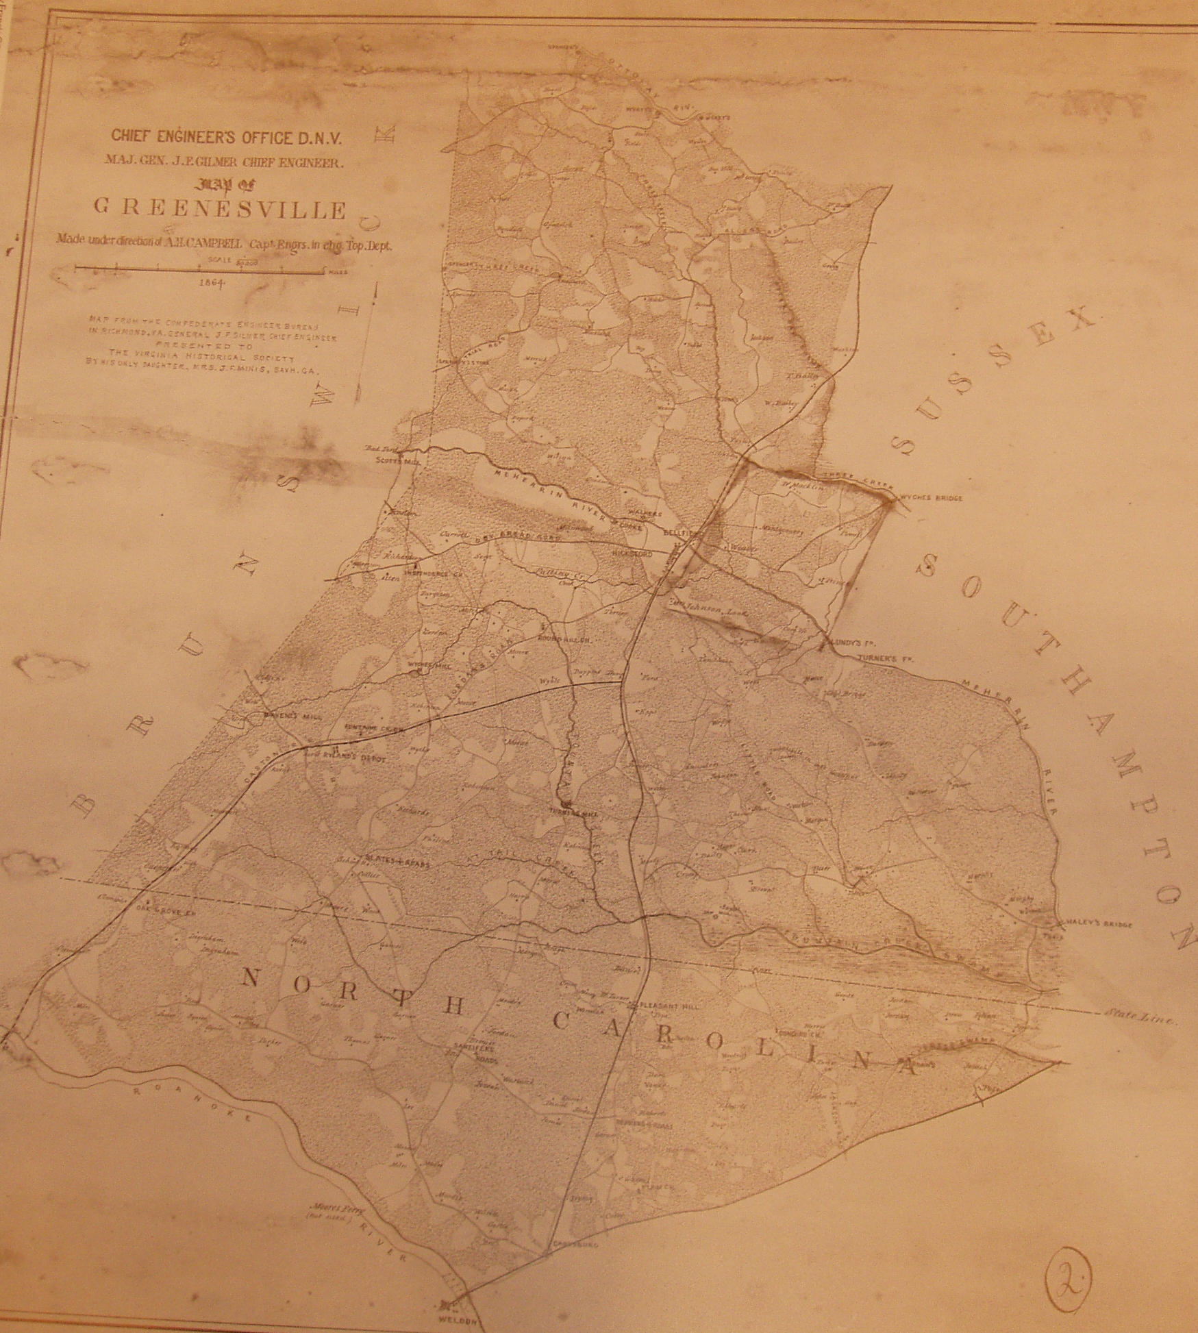

*Figure 6. Gilmer Map 44 drawn in 1864. Area illustrated is Greensville County VA region including northwestern Northampton County NC. Horizontal line is NC/VA border, Roanoke River is on lower left, lowermost feature is township of Weldon.*

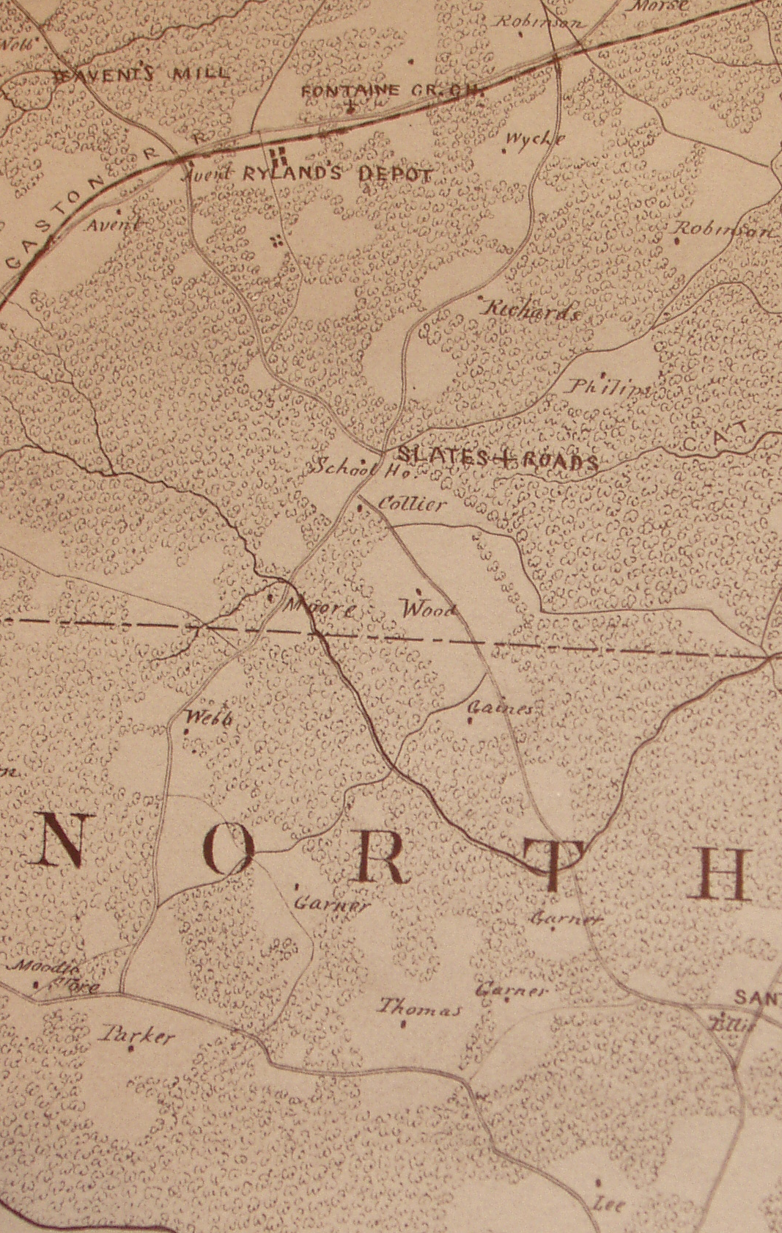

Figure 7. Detail of Gilmer Map 44. Area illustrated is northwestern Northampton County, NC region. Creek that crosses NC/VA border is Beaver Dam Creek*. Note location of Fontaine Church.*

Analysis of the sites immediately bracketing the Gaston region was given priority as this region is believed to be the site of plantations owned by the Colonial Planter Rev. William Garner Sr. (~1745-1824). The map identifies **four distinct Garner plantation sites** labeled as sites a, b, c, and d. To identify potential plantation sites, the locations of the Gilmer map Garner plantations were compared with cemeteries located on USGS topographical maps. It was assumed that home sites occupied over several generations may also have family graveyards which may still be identified in detailed topological maps.



*Figure 8. USGS topological map of Gaston area, Northampton County, NC. Black Duck Creek (Falling Run) is at lower left and Beaver Pond Creek is stream crossing NC/VA border. Garners Mill is at upper left. Road bed of the 'main road' follows NC HWY 46. Hypothesized Northampton Garner allied plantation sites A, B, C represent USGS Map unnamed cemeteries.*

|  |  |  |  |
| --- | --- | --- | --- |
| **Site** | **Location** | **Status** | **Key Evidence** |
| a | Westernmost, Gum Forks area | Estimated | Near Falling Run (Black Duck Creek) — William Sr.'s 1790 patent |
| b | South of Gaston | CONFIRMED | Dr. Presley Killingsworth Garner graveyard |
| c | NE of Gaston, Hwy 48 | CONFIRMED | "James Garner built 1825" chimney inscription; Henry Garner cemetery |
| d | Easternmost, near Beaverdam Creek | Estimated | Roads named for Garners in vicinity |

## 7.2 Site A: The Falling Run Patent Property (Gum Forks Area)

Analysis of USGS map sites west of present Gaston in the Gum Fork Region indicated a cemetery and potential plantation site. Factors contributing to this hypothesis were: proximity to Site B, proximity to cemeteries of the Moody and Squire families (who were allied with early to mid-19th century Garners), and importantly, proximity to the vicinity of the **Falling Run patent of William Garner**.

Falling Run is now known as **Black Duck Creek**. The instructions to the surveyor in William's 1790 patent were:

*"Survey for Wm Garner a tract or parcel of land containing two hundred acres lying in Northampton County between his lines and Nathaniel Norwoods lines and on the main road and on the north side of the Falling Run."*

These properties were joined together along the lines of the Falling Run. These are the properties given to **Samuel Garner** in William's 1824 will.



*Figure 9. West Gaston Potential Garner Plantation Site A (USGS Detail of Gum Fork Area). Shows cemetery location, proximity to Moody Cemetery, Bethany Church, and Squire School.*

The area of Site A was explored in winter of 2005 with a focus on the unmarked cemetery identified in the USGS map. This site contained several marked graves of indeterminate age and a number of mid-20th century graves. While no definitively identifiable Garner graves were found, this does not rule out the potential that this was used as an early Garner graveyard.

## 7.3 Site B: Dr. Presley Killingsworth Garner Graveyard

Site B on the USGS map was positively identified through interviews and site visits. Present at this location are graves of **Dr. Presley Killingsworth Garner (1835-1861)**, E.I. Thomas, and Susan Garner Thomas from the mid-19th century.

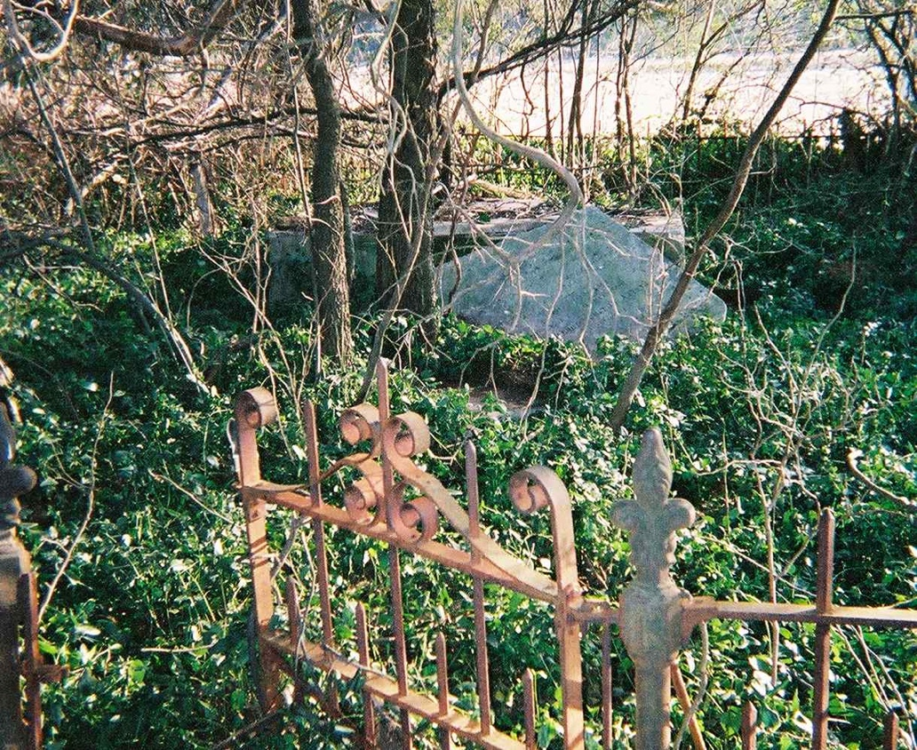

*Figure 10. Presley Killingsworth Garner Graveyard, Gaston NC. Iron fence surrounds cemetery with marble gravestone visible.*

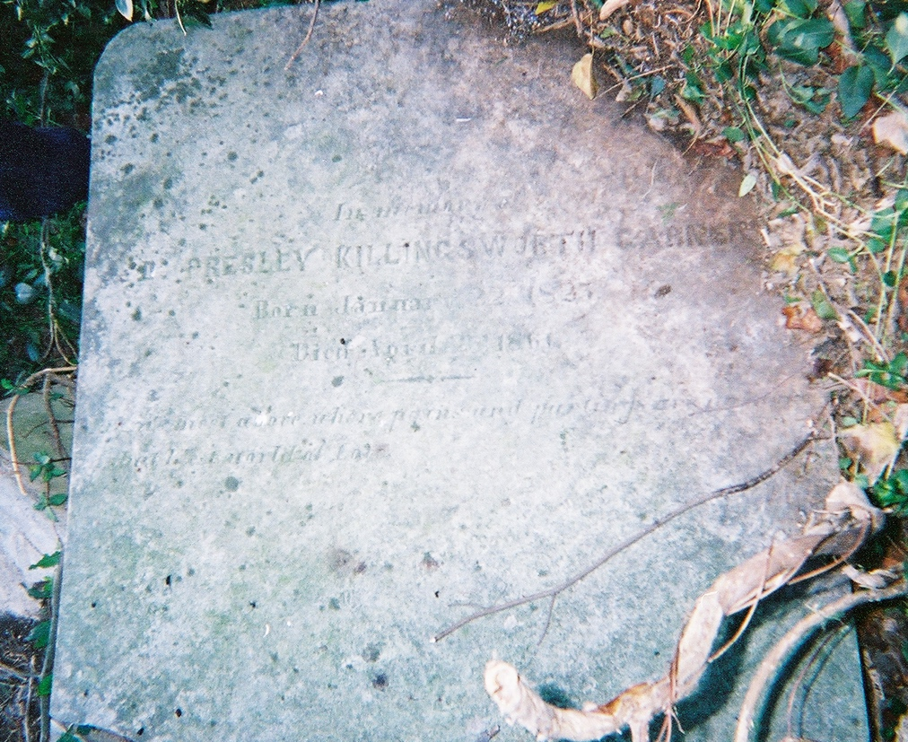

*Figure 11. Presley Killingsworth Garner (1835-1861) Gravestone, Gaston NC. Inscribed: 'In Memory of Presley Killingsworth Garner / Born [date] / Died April [?] 1861'*

In his will probated in Northampton County 1861, Dr. P.K. Garner requested that his "body be buried in the graveyard of his brother-in-law E.I. Thomas." Thus this point represents the location of the Thomas property, marked "b" on the Gilmer Map. The site shows evidence of a dwelling: presence of dwelling symbols on older maps, hand-formed bricks in piles suggesting a collapsed dwelling, and tree growth in rectilinear patterns suggesting growth around a once-standing structure.

*Figure 12. Detail of Gilmer Map 44 showing Gaston region Garner and allied plantations. Sites labeled: a (Garner), b (Thomas), c (Garner), d (Garner).*

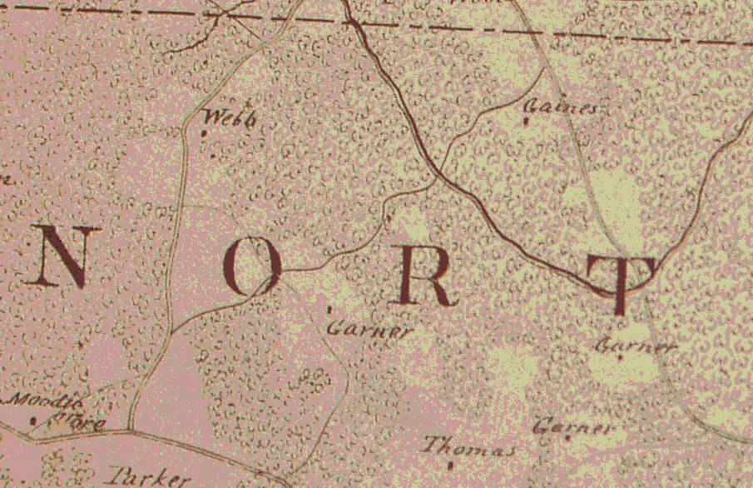

a

b

c

d

**Significance:** The existence of Dr. **Presley** Killingsworth Garner—grandson of Rev. William Garner Sr.—confirms that the name "Presley" was honored within the direct Garner line. This strongly supports the family connection to Presley Garner (1757-1837) of South Carolina, who witnessed Samuel Garner's deeds and signed the 1787 Greensville partition petition.

## 7.4 Site C: The 1825 James Garner Manor House

Site C, located off Hwy 48 approximately 1.25 miles north of Gaston, was confirmed as a Garner plantation through an inscription in the chimney masonry: **"James Garner built 1825."** The house was pushed down and buried in the early 1990s, but photographs were taken prior to demolition.

The present owner of the property showed the author the house site and the graveyard (approximately 0.5 miles off highway) and confirmed that the property was the site of an old Garner "Big House." The cemetery was overgrown severely; several Garner graves were found supporting that the site was occupied by the Garners during the late 18th century.



*Figure 13. East Gaston Garner Plantation USGS Site B and USGS Site C Cemeteries. Shows locations of Dr P K Garner and Captain E I Thomas Cemetery at Gilmer Map Site, and Gilmer Map Garner Site 'Built 1825' Cemetery Extant.*

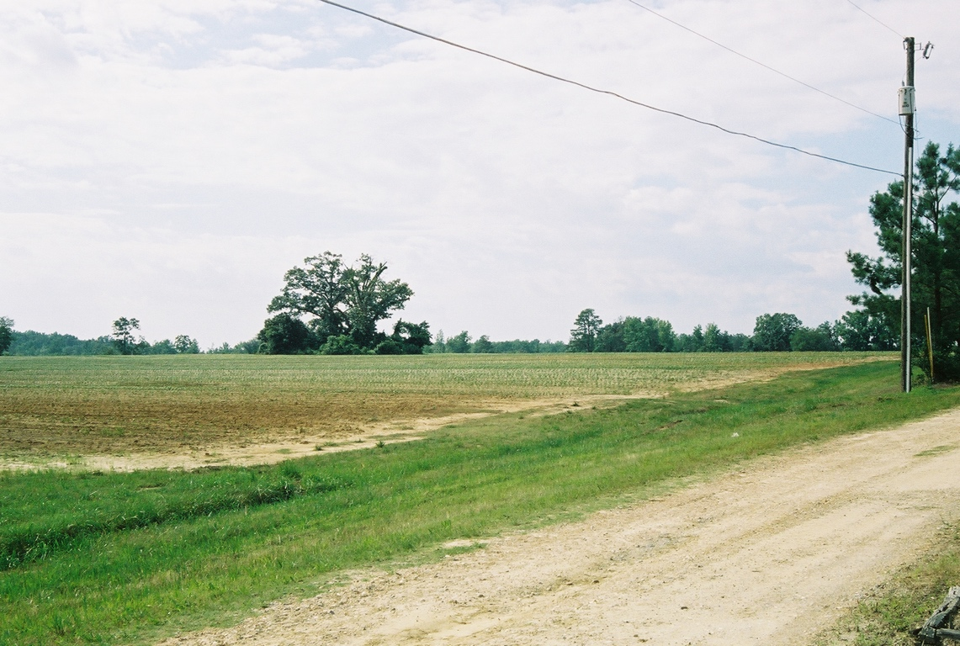

*Figure 14. Site of 1825 Garner Manor House site and Graveyard. View from road showing field with tree line marking cemetery location.*

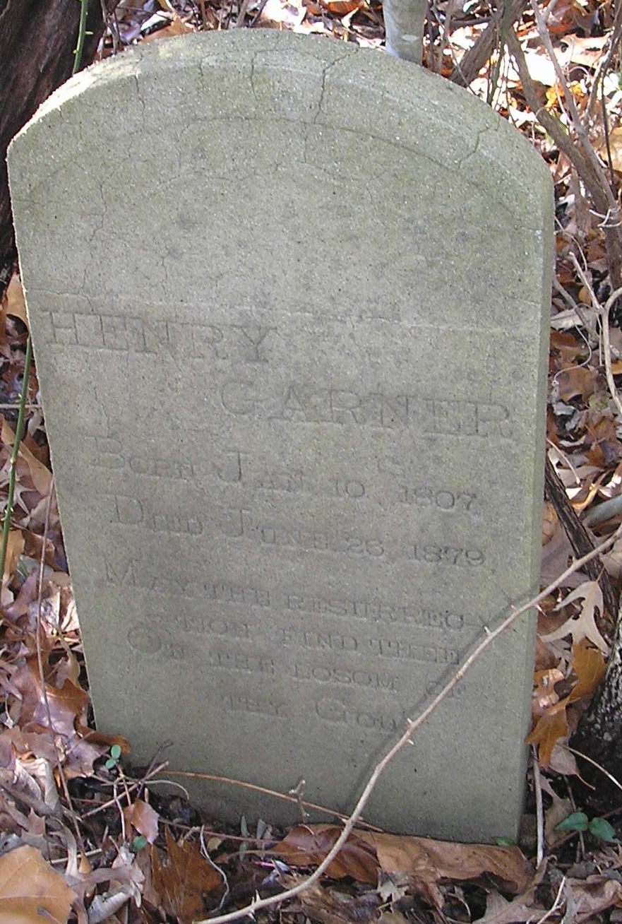

*Figure 15. Henry Garner Gravestone uncovered during visit to USGS Site C. Inscribed: 'HENRY GARNER / Born Jan 10 1807 / Died June 26, 1879 / May the Resurrection Find Thee on the Bosom of thy God'*

### Identity of James Garner

Deed records confirm that the James Garner who built this house was **James M Garner**, son of John Garner and **grandson of Rev. William Garner Sr.** The 1848 estate division of John Garner (Northampton Deed Book 33, Page 87) identifies his children as Henry, James M, Richard H, and Thomas J Garner.

James M Garner's deed trail confirms his activity in the Gaston area:

|  |  |  |
| --- | --- | --- |
| **Date** | **Transaction** | **Reference** |
| 5/15/1821 | James sold land to Abner Bynum | Bk 20 Pg 480 |
| 1825 | "James Garner built 1825" (chimney inscription) | Site C |
| 12/7/1848 | James M inherited share in John Garner's estate division | Bk 33 Pg 87 |
| 3/20/1857 | James M purchased from George Harding | Bk 36 Pg 457 |
| 6/4/1858 | James M purchased from Thomas J Garner (brother) | Bk 37 Pg 71 |
| 11/18/1859 | James M sold to P K Garner (Dr. Presley Killingsworth, nephew) | Bk 37 Pg 495 |

**Significance:** The 11/18/1859 deed shows James M Garner selling land to his nephew Dr. Presley Killingsworth Garner, keeping the property within the family. This transaction occurred just two years before Dr. P.K. Garner's death in 1861.

### Construction Details

The manor house construction reveals the substantial wealth of the Garner family by the 1820s:

* 2½ story frame house built over **7 years by enslaved labor**
* First portion: hand-hewn timber
* Second addition: mill-sawn timbers from the **Garners' own sawmill**
* All joints mortised and pegged
* Foundation stones carted from the Roanoke River
* Dug foundation partly buried for coolness
* Interior walls plastered with horse and/or hog hair as binder
* Stone steps to raised second-floor principal entrances (front and back)

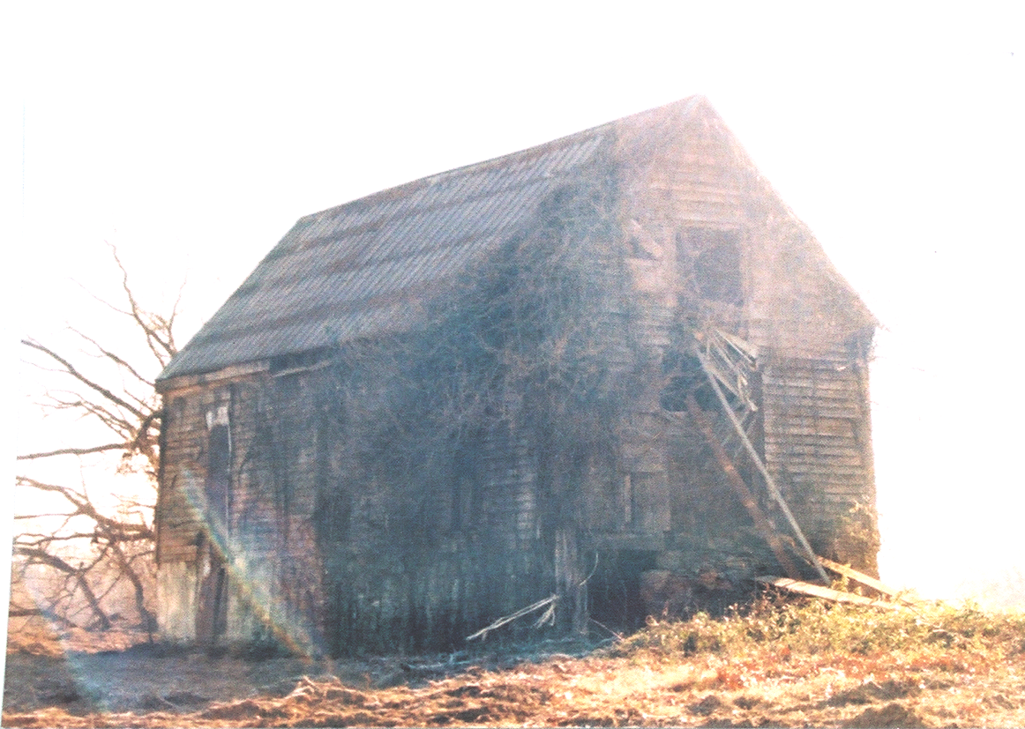

*Figure 16. Western view of 1825 Garner Manor House (USGS map site C). 2½ story frame house with tin roof (not original), showing deteriorated condition prior to demolition.*

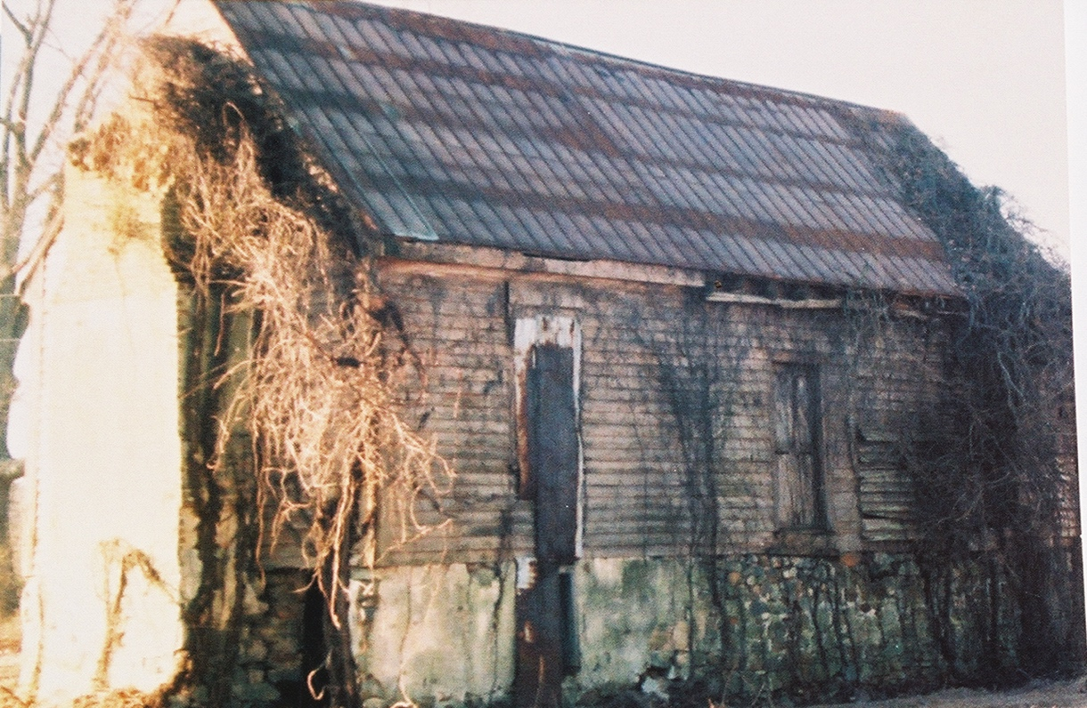

*Figure 17. Western view of 1825 Garner Manor House (USGS map site C). Shows stone foundation from Roanoke River and original siding.*

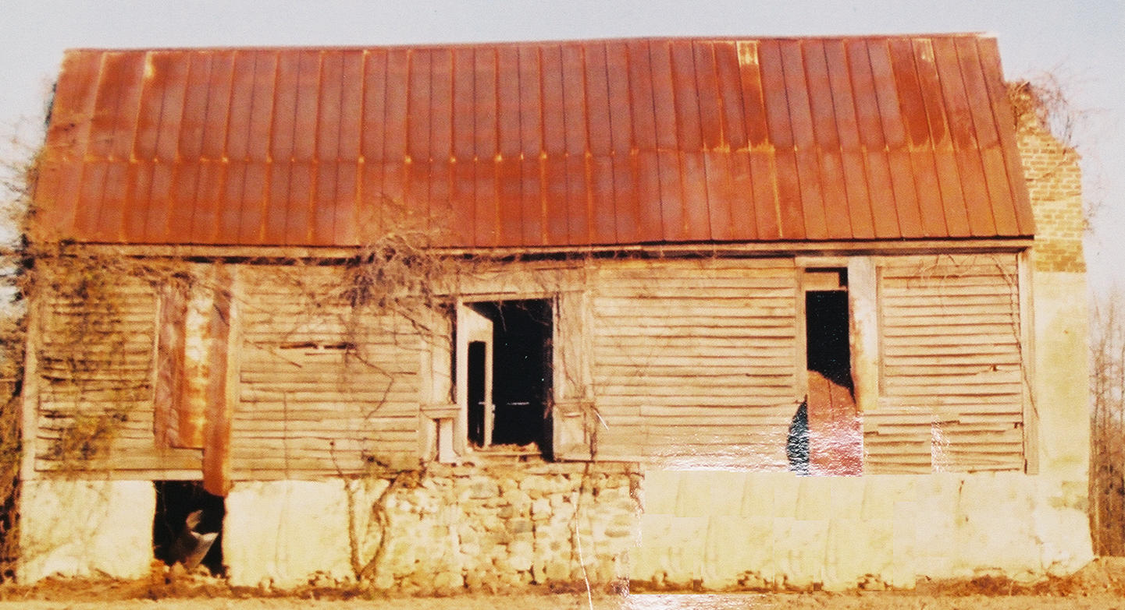

*Figure 18. Frontal view of 1825 Garner Manor House (USGS map site C). Shows raised foundation with stone steps (porches removed prior to demolition).*

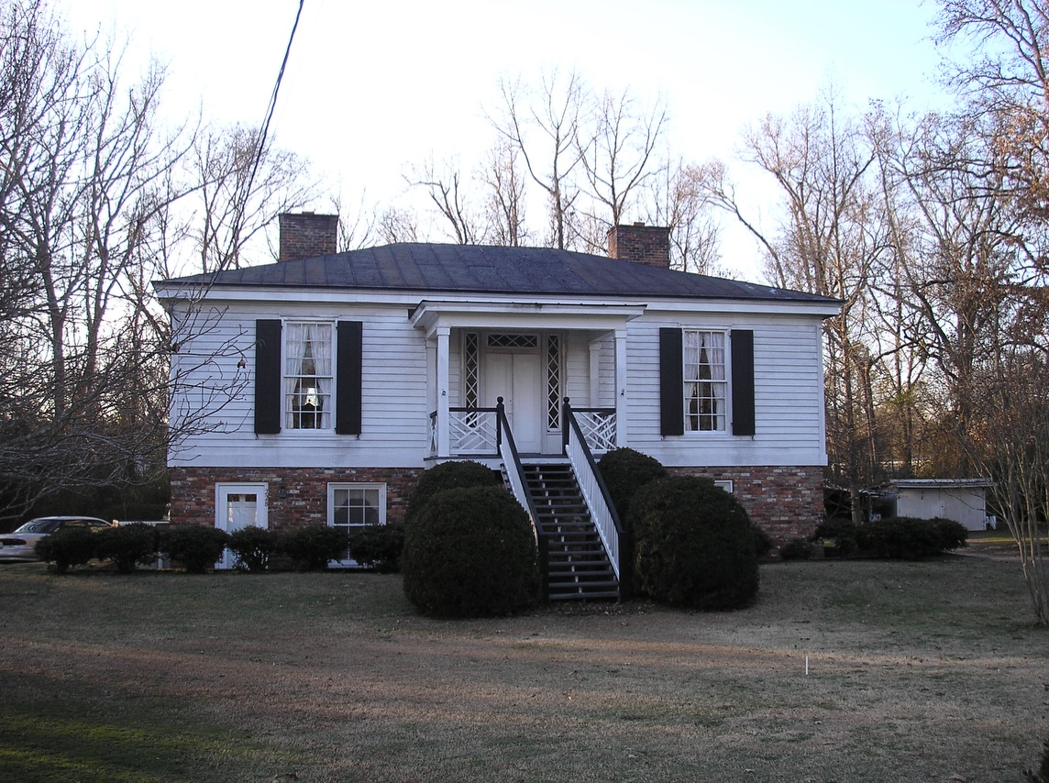

*Figure 19. Ivey house, Halifax, NC, built 1847. This house is a prototypical Roanoke Valley farm house and similar in design to the James Garner house, showing how the structure would have appeared when complete.*

### John Garner's Children: The 1848 Estate Division

The 1848 estate division of John Garner (Northampton Deed Book 33, Page 87) definitively identifies his four sons:

|  |  |  |
| --- | --- | --- |
| **Name** | **Dates** | **Notes** |
| Henry Garner | 1807-1879 | Buried at Site C; married Sarah Jane (1804-1864) |
| James M Garner | Active 1821-1859 | Built the 1825 manor house (Site C) |
| Richard H Garner | Active 1831-1869 | Sheriff of Northampton Co.; NC Representative |
| Thomas J Garner | Active 1848-1860 | Land transactions with siblings |

### Henry Garner Cemetery Transcription

The cemetery at Site C contains graves of Henry Garner (son of John, grandson of Rev. William Garner Sr.) and his descendants:

|  |  |  |
| --- | --- | --- |
| **Name** | **Dates** | **Notes** |
| Henry Garner | Jan 10, 1807 – June 26, 1879 | Son of John Garner Sr., grandson of Rev. William Garner Sr. |
| Sarah Jane Garner | May 10, 1804 – Apr 15, 1864 | Wife of Henry Garner |
| John G. Garner | d. May 14, 1896 (age 81) | Son of Henry (b. ~1814) |
| Martha J. Garner | d. May 2, 1907 (age 70) | Wife of J.G. Garner |
| Joseph H. Garner | Aug 16, 1864 – Jan 18, 1880 | Son of J.G. and Martha |
| W. Paul Garner | 1871–1945 | Descendant |
| 4 unmarked depressions | Unknown | Possibly earlier generations |

## 7.5 Site D: Estimated Location (Easternmost Plantation)

The positive identification of two out of the four Gilmer Garner allied plantation sites presented an opportunity for the location of the remaining sites via simple geometric techniques. On the Gilmer Map, the distance between site b and c (distance bc) is approximately equivalent to the distance between sites c and d (distance bc≈cd). Additionally, the distance between the westernmost site a and the easternmost site d is approximately 3 times the distance bc (distance ad≈3bc).

By drawing a circle of radius bc from the location of site c, the approximate position of site d can be surmised as the intersection of that circle with the road just south of where it crosses Beaverdam Creek. Location of the ruins of manor house at the potential site of the easternmost plantation "d" was not evident from roadside observation. However, in the region of this site, there are **several roads named for Garners** and the presence of the households of several Garner families, suggesting a longtime presence of those carrying this name.



*Figure 20. Location of Garner Plantations on USGS map. Shows geometric estimation of plantation site locations using circles of radius bc, 2bc, and 3bc from confirmed sites. Henry Garner Cemetery marked as 'c', P K Garner / E I Thomas Cemetery marked as 'd'. Possible locations of 'a' and 'd' plantations indicated.*

## 7.6 Property Succession: The Falling Run Patent

Documentary evidence traces the succession of Rev. William Garner Sr.'s 1790 Falling Run patent (200 acres), confirming family relationships:

1. **Rev. William Garner Sr.** (1790 patent: "Survey for Wm Garner a tract or parcel of land containing two hundred acres... on the north side of the Falling Run")
2. **Samuel Garner** (son) — received property in 1824 will; petitioned court for partition 1835
3. **William Garner Jr.** (son) — received remainder after partition
4. **Thomas Garner** (son of Samuel) — inherited from William Jr.
5. **Bradford Garner** (brother of Thomas) — inherited from Thomas
6. Sold to Turner family (explaining "Turner" road names in the area today)

**Note:** Falling Run is now known as Black Duck Creek on modern USGS maps.

## 7.7 Geographic Significance

The geographic evidence from the Gilmer Map and USGS surveys confirms several key findings:

* **Concentrated settlement:** Four Garner plantation sites clustered around present-day Gaston, NC
* **South of Meherrin:** All identified sites are south of the Meherrin River, consistent with the "South of Meherrin" Garner clan identified through documentary and Y-DNA evidence
* **Industrial capacity:** "Garners Mill" appears on USGS maps, indicating family sawmill operations that supplied lumber for the 1825 manor house
* **Multi-generational presence:** Cemeteries at Sites B and C contain burials spanning 1807-1945, demonstrating continuous Garner family occupation
* **Naming pattern confirmed:** Dr. Presley Killingsworth Garner's grave at Site B proves the name "Presley" was honored in Rev. William Garner Sr.'s direct line
* **Economic prosperity:** The 1825 manor house (7 years construction, enslaved labor, own sawmill, Roanoke River stones) demonstrates substantial family wealth within one year of Rev. William Garner Sr.'s death
* **Garner Mill:** "Garners Mill" appears on USGS maps; the mill dam is extant, confirming family industrial operations
* **Extant structures:** The R.H. Garner (Richard H. Garner, Sheriff of Northampton County) plantation manor house remains extant
* **Additional cemeteries:** P.K. Garner Jr. cemetery located behind Lebanon Church; Moody Cemetery associated with allied families
* **Land acquisition:** William Garner purchased land from Sprayberry (1784) and from Simon Lane's patent, establishing the family's presence in the region

# Section 8: The Slave Named "Lamar"

## 8.1 Evidence from William Garner's 1824 Will

Perhaps the most striking piece of documentary evidence supporting the LaMar connection comes from Rev. William Garner's own will, probated in Northampton County, North Carolina in December 1824. Item 7 states:

*"Item 7th. I lend to my daughter Francis Walpole the use of one negro man by the name of* ***Lamar*** *also one negro woman by the name of Susan which she has in her possession also one negro boy by the name of Isam and at her death I give the said negroes to be equally divided among her children."*

## 8.2 Significance of the Name

"Lamar" is a highly unusual name for an enslaved person in early 19th century Virginia/North Carolina. Enslaved people were typically given:

* Common English names (John, Peter, Harry, etc.)
* Classical names (Caesar, Pompey, etc.)
* Names of family members or patrons

"Lamar" fits none of the typical categories—**unless it was a name of personal significance to William Garner**. The naming of an enslaved person after one's biological father's family would be a subtle but meaningful acknowledgment of origins that could not be publicly declared.

## 8.3 Interpretive Caution

While the presence of this name is suggestive rather than conclusive on its own, when combined with:

1. Definitive Y-DNA evidence of LaMar paternity
2. The "son-in-law William" designation in Thomas LaMar's 1747 will
3. The precise timeline alignment (William Garner b. c. 1745, Thomas LaMar d. 1747)
4. Multi-generational geographic proximity of both families

...the naming of an enslaved man "Lamar" becomes a compelling additional piece of circumstantial evidence supporting William Garner's awareness of his biological origins.

# Section 9: Evaluation of Alternative Hypothesis

## 9.1 The Southampton County Record

A potentially conflicting record exists from Southampton County, Virginia (1754):

*Anne Garner, servant of Isaac Mason, gave a "mulatto child William Garner" to the Southampton County Virginia Church Wardens in 1754. Ann gave three children, all indicated as "mulatto," including her son William, to the wardens. However, this particular William was not bound to local landowners as the other two children were.*

## 9.2 Why This Record Likely Refers to a Different Individual

1. **Social Standing:** Rev. William Garner was literate, served as Anglican Vestry Clerk, and became a Baptist minister. A child designated "mulatto" and surrendered to churchwardens would have faced significant barriers to such positions in colonial Virginia.
2. **Geographic Network:** Rev. William Garner's social network points to Maryland (Goodrums, Goldie), not Southampton County.
3. **Not Bound Out:** The fact that this William was "not bound to local landowners" could suggest someone claimed him—but if so, we would expect records of that arrangement.
4. **Y-DNA Evidence:** The definitive LaMar Y-DNA match points to a specific, documented origin that explains the genealogical brick wall much more coherently than the Southampton record.

**Conclusion:** The Southampton County record most likely refers to a different William Garner, or the "mulatto" designation was applied loosely/erroneously. The preponderance of evidence strongly favors the Maryland/LaMar origin for Rev. William Garner.

# Section 10: Migration Patterns of LaMar-Y-DNA Garner Lines

Analysis of the geographic distribution of Garner/Gardner families carrying LaMar Y-DNA reveals distinct migration corridors and settlement patterns from the Maryland origin point to multiple destinations across Virginia, North Carolina, and South Carolina.

## 10.1 Geographic Distribution

The LaMar-Y-DNA Garner lines settled in five known primary locations:

|  |  |  |
| --- | --- | --- |
| **Region** | **Location** | **Dates Active** |
| Maryland (Origin) | Patuxent River, Calvert/Prince George's Co. | 1680s-1747 |
| Southside Virginia | Brunswick/Greensville Counties | 1750s-1820s |
| NC/VA Border | Northampton County, NC | 1770s-1900s |
| NC Piedmont | Surry County, NC | 1790-1800s |
| NC Piedmont Interior | Chatham County, NC (Haw River) | 1796-1827 |
| NC Foothills | Rutherford/Cleveland Counties, NC | 1770-1900s |
| Central South Carolina | Richland County, SC | 1790-1837 |

## 10.2 Timeline of Settlement

Documentary evidence establishes the following chronology of Garner/Gardner settlement:

|  |  |  |  |
| --- | --- | --- | --- |
| **Date** | **Location** | **Individual** | **Evidence** |
| 1677-1722 | Patuxent River, MD | John Garner (d. 1722) | Will, Calvert Co. |
| 1747 | Prince George's Co., MD | Thomas LaMar (d. 1747) | Will: "son-in-law William" |
| 1770 | Rutherford Co., NC | William Gardner | Land grants, Gov. Martin |
| 1772-1780 | Northampton Co., NC | William Garner | Deed records |
| 1780 | Brunswick Co., VA | Rev. William Garner Sr. | Marriage to Lucy Johnston |
| 1787 | Greensville Co., VA | Rev. William Garner Sr. | Fountain Creek Baptist |
| 1790 | Richland Co., SC | Presley Garner | Garner's Ferry established |
| 1790 | Surry Co., NC | William, John, Wyatt Garner | Census |
| 1793 | Brunswick → Surry NC | William Garner (Samford) | Power of Attorney |
| 1796 | Chatham Co., NC | Samuel Garner | Deed (from Greensville Co) |
| 1798-1799 | Rutherford Co., NC | William, Thomas, James, Daniel | Court records |
| 1807 | Rutherford Co., NC | William Sr., William Jr., Thomas | Deed Book 24 |
| 1809 | Chatham Co., NC | Samuel Garner | Will (unprobated) |

## 10.3 Identified Migration Corridors

### Corridor 1: The Great Wagon Road (North-South)

Maryland → Shenandoah Valley → NC Piedmont → SC

This major colonial migration route explains the **Rutherford/Cleveland County** settlement (1770) and the **Richland County, SC** settlement (Presley Garner, 1790). Families following this corridor moved through the backcountry, avoiding the coastal plantation regions.

### Corridor 2: The Fall Line / Trading Path (East-West)

Tidewater VA/NC → Piedmont NC interior

This corridor connects Brunswick/Northampton to **Chatham County (Haw River)**. Samuel Garner maintained property in BOTH locations simultaneously (Greensville VA and Chatham NC), suggesting economic opportunity drove the Chatham expansion rather than permanent relocation.

### Corridor 3: Southside Virginia / NC Border

Brunswick/Greensville VA ↔ Northampton NC

This was the **core family territory** where Rev. William Garner Sr., Samuel Garner, and Presley Garner (before his SC move) maintained their primary residences. The state line bisected their community; short-distance moves across the border were common as families held property in both jurisdictions.

### Corridor 4: Piedmont NC (Northwest)

Brunswick → Surry County, NC

William Garner (husband of Mary Samford) relocated with the **Samford family** to Surry County by 1790-1793. This migration was tied to his wife's family network rather than the core Garner clan. The 1793 Power of Attorney listing William Garner alongside William Keen Samford, Joseph Samford, and James Samford confirms this family-group migration.

## 10.4 Key Observations

### Earliest Dispersal Predates Core Family Records

The Rutherford County line (**1770**) predates the documented Brunswick/Northampton presence of Rev. William Garner Sr., suggesting the LaMar-Garner connection may have produced **multiple sons who dispersed before the 1770s**. William Gardner of Rutherford County (b. ca 1740-1749) was the same generation as Rev. William Garner Sr. (b. c.1745).

### Dual Residency Pattern

Samuel Garner maintained property in **both** Greensville VA and Chatham County NC (Haw River) — his 1796 deed identifies him as "Samuel Garner of the County of Greensville" while purchasing land in Chatham County. This dual residency suggests economic opportunity (possibly related to the Haw River trade) drove the Chatham expansion.

### Family Network Migration

Presley Garner's move to South Carolina brought **"nephews" Edmund L. and Thomas L. Garner** with him. Family units moved together, maintaining kinship networks across state lines. This pattern suggests coordinated family decisions rather than individual opportunism.

### Return Migration

Wyatt Garner appears in Northampton County by 1850 after his family was initially established in Surry County in 1790 — representing a **return to ancestral territory**. His daughter "Lucy E. Garner" suggests family memory persisted across generations and geography.

## 10.5 Hypothesis: Multiple Brothers Dispersing from Maryland

The geographic pattern suggests that **Thomas LaMar (d. 1747)** may have fathered multiple sons by Garner women, who then dispersed along different migration corridors:

* **Brunswick/Northampton line:** Rev. William Garner Sr., Samuel Garner (confirmed brothers by Y-DNA)
* **Rutherford/Cleveland line:** William Gardner (ca 1740-aft. 1807), arrived 1770 with land grants
* **Possible additional lines:** Other Garner/Gardner families carrying LaMar Y-DNA may yet be discovered

The **1770 date** for William Gardner in Rutherford County is significant — he would have been born ca. 1740-1749, making him the **same generation** as Rev. William Garner Sr. (c.1745). Possible relationships include:

* **Full brothers:** Same LaMar father and same Garner mother
* **Half-brothers:** Same LaMar father, different Garner mothers
* **Cousins:** Different LaMar fathers (e.g., Thomas and a brother), both children taking Garner surname

The **direct Y-DNA match with a Samuel LaMar (ca 1764-1827) descendant** confirms the genetic connection to the LaMar line is real and not coincidental. The multiple Garner/Gardner lines carrying this Y-DNA signature represent a significant pattern of illegitimate births within or connected to the LaMar family, with children consistently taking the Garner/Gardner surname from their mothers.

# Section 11: Synthesis and Conclusion

## 11.1 Personal Patrilineal Descent: The Researcher's Direct Line

This research establishes a documented patrilineal descent from the French Huguenot LaMar family of Maryland to the present-day researcher, C. Edwin Garner:

|  |  |  |
| --- | --- | --- |
| **Gen.** | **Individual** | **Notes** |
| 1 | Thomas LaMar Sr. (1630/1641-1714) | French Huguenot born Anjou, France later immigrant to Maryland |
| 2 | John LaMar I (1690-1758) | Calvert/Prince George's County, MD |
| 3 | Thomas LaMar (d. 1747) | Will names "son-in-law William"; biological father |
| 4 | Rev. William Garner Sr. (c.1745-1824) | Baptist minister; Revolutionary War veteran; m. Lucy Johnston 1780 |
| 5 | Samuel Garner (d. after 1841) | Son of William Sr.; Northampton Co.; sons Thomas & Bradford |
| 6 | Bradford Garner (d. after 1860) | Moved to Halifax County, NC; m. Milley |
| 7 | James Henry Garner (1845-1891) | Civil War veteran (32nd NC Infantry); m. (1) Lucy Green, (2) Eliza W. Glasgow |
| 8 | Archer Lee Garner (1890-1968) | Son of 2nd marriage; m. Ada L. Fulgum 1913; trustee Smith Methodist Church |
| 9 | Claude Wilson Garner (1916-2001) | m. Laura Elizabeth Pearson Jan 11, 1938; purchased Garner Farm 1962 |
| 10 | Clarence Edwin Garner (1939-1988) | m. Margaret June 28, 1963; named for uncle Clarence Edwin Fulgham (d. 1939) |
| 11 | Clarence Edwin Garner II, PhD (b. 1966) | Researcher; Y-DNA tested; Kit #93186 |

### James Henry Garner: Civil War Service

James Henry "Jim" Garner served in the Confederate Army, surrendering with his unit at Appomattox Court House at the end of the Civil War:

|  |  |
| --- | --- |
| **Field** | **Detail** |
| Full Name | James Henry "Jim" Garner |
| Birth | February 12, 1845, Northampton County, NC |
| Death | February 26, 1891, Weldon, Halifax County, NC (age 46) |
| Unit | Company C, 32nd North Carolina Infantry Regiment (Confederate) |
| Enlistment | June 20, 1863, Northampton County, NC (age 18) |
| Surrender | April 9, 1865, Appomattox Court House, Virginia |
| First Marriage | Lucy Green, August 21, 1867, Halifax, NC |
| Second Marriage | Eliza Winnifred Glasgow (Nov 1864-1946) |
| Source | North Carolina Troops 1861-65, A Roster |

Bradford and Milley Garner had **three sons who enlisted in the Confederate Army**: Albert W., John, and James Henry. James Henry Garner is the great-great-grandfather of the researcher.

### James Henry Garner's Descendants

A 1977 affidavit by **Raymond Garner, Grandson of James Henry Garner**  (notarized by O. Max Gardner Jr., Halifax County, NC) documents that James H. Garner died in 1891 survived by his wife Eliza W. Garner (who died in 1946) and **seven children** from two marriages. The affidavit did not specify which children belonged to which marriage, but family records confirm the following:

**First Marriage: Lucy Green** (married August 21, 1867, Halifax, NC; died 1881)

Children:

* Alonzo Thomas "Lonnie" Garner (1868 – January 11, 1930)
* Musie G. Garner Summerell (d. 1943) — four children
* Lonnie T. Garner (d. January 11, 1930) — m. Nellie V. Garner (d. March 11, 1959); six children
* Minnie G. Garner Harrison (d. December 29, 1898) — m. Alonza Harrison; one child
* Lillie G. Garner Summerell (d. March 30, 1900) — m. Eddie V. Summerell; one child
* Albert Wilson Garner (September 9, 1878 – July 15, 1935) — six children including Raymond Garner (affiant)

**Second Marriage: Eliza Winnifred Glasgow** (married February 13, 1883; November 1864, Aurelian Springs – April 5, 1946)

Children (two only):

* **Archer Lee Garner** (November 28, 1890 – September 18, 1968) — m. Ada L. Fulgum; the researcher's direct ancestor
* **Jesse R. Garner** (c. 1891 – October 6, 1930) — died unmarried, no children

**Note:** Both Archer Lee and Jesse R. were infants when their father James Henry died (February 1891). They were raised by their mother Eliza Winnifred Glasgow, who "looked after the farm as long as she could, and then had to depend on sharecroppers until her death" (from "The Garner Farm" article submitted by Claude Garner).

**Archer Lee Garner** married Ada L. Fulgum (January 17, 1893 – February 10, 1980) on August 20, 1913. He was a **trustee and steward of Smith Methodist Church** in Roanoke Rapids. Per his obituary, he died at age 79 and was buried in **Crestview Memorial Cemetery**. His children included:

* Elwyn Morehead Garner (July 19, 1914 – May 27, 1988)
* **Claude Wilson Garner** (December 25, 1916 – February 15, 2001); married Laura Elizabeth Pearson
* George Fulgram Garner (July 27, 1920 – February 5, 2004)
* Archer L. Garner Jr. (c. 1923)

### The Garner Farm and Claude Wilson Garner

An article titled "The Garner Farm" (**submitted by Claude Garner**) documents the family's Halifax County land:

* **1868:** James H. Garner bought the first land in Halifax County
* **1878:** James H. Garner purchased additional land; owned and operated a **cotton gin**
* **January 16, 1962:** Archer L. Garner purchased the farm shares from his brothers and sisters and sold the farm to his son Claude W. Garner

"All of this family was born in a four room house. Claude was born here. Claude has one son, **Fred W. Garner**, living on this farm now who will be taking it over when Claude retires. Fred is very much interested in keeping the farm in the Garner family and maintaining interest in farming."

### Claude Wilson Garner's Family

**Claude Wilson Garner** married **Laura Elizabeth Pearson** on January 11, 1938 at the R.R. Methodist Parsonage (Roanoke Rapids), officiated by G. L. Rogers. Witnesses included George Garner, Tempie Pearson, and Albert “Snook” Garner (per the family Bible marriage certificate).

Their children (from family Bible records):

* **Clarence Edwin Garner** (January 24, 1939 – November 28, 1988) — named for his uncle **Clarence Edwin Fulgham**, who died in a train accident just before his birth in 1939; married Margaret June 28, 1963
* Fred Wilson Garner (March 19, 1951) — continues the family farming tradition
* Lewis Earl Garner (July 22, 1952 – December 19, 2006) — graduate of Western Carolina University

### The Researcher: Clarence Edwin Garner II, PhD

The researcher, **Clarence Edwin Garner II, PhD** (born 1966), is the son of Clarence Edwin Garner and Margaret. He represents the continuation of the LaMar Y-DNA through **eleven documented generations** from the French Huguenot immigrant Thomas LaMar Sr. (1630/1641-1714) to the present day. His Y-DNA test (Kit #93186) provided the genetic evidence that confirmed the LaMar-Garner biological connection.

## 11.2 The Reconstructed Narrative

Based on the convergence of Y-DNA evidence and documentary analysis, the following narrative emerges:

**c. 1677-1714:** Thomas Lamar, Sr., a French Huguenot immigrant, establishes "The Fishing Place" plantation at Golden Beach on the Patuxent River in St. Mary's County, Maryland. The Garner family (John Garner, planter) resides nearby at the mouth of St. Leonard's Creek in Calvert County.

**c. 1720-1745:** Descendants of both families continue to interact along the Patuxent. Thomas LaMar (son of John Lamar I, grandson of Thomas Lamar Sr.) has a relationship with a woman of the Garner family—likely a granddaughter of John Garner of Calvert County.

**c. 1745:** William is born to this union. Being illegitimate, he takes his mother's surname: Garner.

**1747:** Thomas LaMar dies, naming William as "son-in-law" in his will to ensure he receives an inheritance despite his irregular status. William is approximately 2 years old and remains with his Garner mother or her family.

**1748-1765:** The orphans court in Frederick County, Maryland oversees the settlement of Thomas LaMar's estate, including provisions for his minor children.

**c. 1760s:** William Garner, now a young adult, migrates south along the established Maryland-to-Virginia corridor, eventually settling in the Brunswick/Northampton border region. His literacy and social standing suggest he received some support or education—possibly from the LaMar family.

**1765-1774:** William establishes himself in Northampton County, NC, serving as Vestry Clerk at St. John's Chapel and purchasing land.

**1780-1781:** During the Revolutionary War, William provides supply and provision services, specifically 40 days of beef driving. This service is documented in Brunswick County, VA records and paid through a Halifax County, NC voucher—both showing 6 pounds—reflecting his unique position as a landholder in both states.

**1787-1824:** William is licensed as a Baptist minister and serves Fountain Creek Church. He names an enslaved man "Lamar"—perhaps a quiet acknowledgment of his biological origins.

**1824:** William Garner dies in Northampton County, North Carolina, leaving a large estate to his descendants.

## 11.3 The Revised Lineage

The biological patrilineal descent of Rev. William Garner is now established as:

|  |  |  |
| --- | --- | --- |
| **Gen.** | **Individual** | **Notes** |
| 1 | Thomas Lamar, Sr. (1630/1641-1714) | French Huguenot immigrant to Maryland |
| 2 | John Lamar I (1690-1758) | Calvert/Prince George's County, MD |
| 3 | Thomas LaMar (d. 1747) | Prince George's County, MD; biological father of William Garner |
| 4 | Rev. William Garner Sr. (c. 1745-1824) | Illegitimate son; Baptist minister; m. Lucy Johnston 1780 |
| 5 | John Garner (d. before 1848) | Son of William Sr.; named in 1822 will; m. Sally |
| 6 | Henry Garner (1807-1879) | Son of John; buried Site C; m. Sarah Jane (1804-1864) |
| 6 | James M Garner (active 1821-1859) | Son of John; built 1825 manor house (Site C) |
| 6 | Richard H Garner (active 1831-1869) | Son of John; executor of P.K. Garner estate |
| 6 | Thomas J Garner (active 1848-1860) | Son of John; land transactions with siblings |
| 7 | Dr. Presley Killingsworth Garner (1835-1861) | Grandson of John; buried Site B; honors Presley & Killingsworth names |

**Parallel Line (Brother of Rev. William Sr.):** Samuel Garner (d. Northampton Co.) — Confirmed by Y-DNA match as biological brother. His son Gideon married Mary Polly Killingsworth, explaining the "Killingsworth" middle name in the next generation.

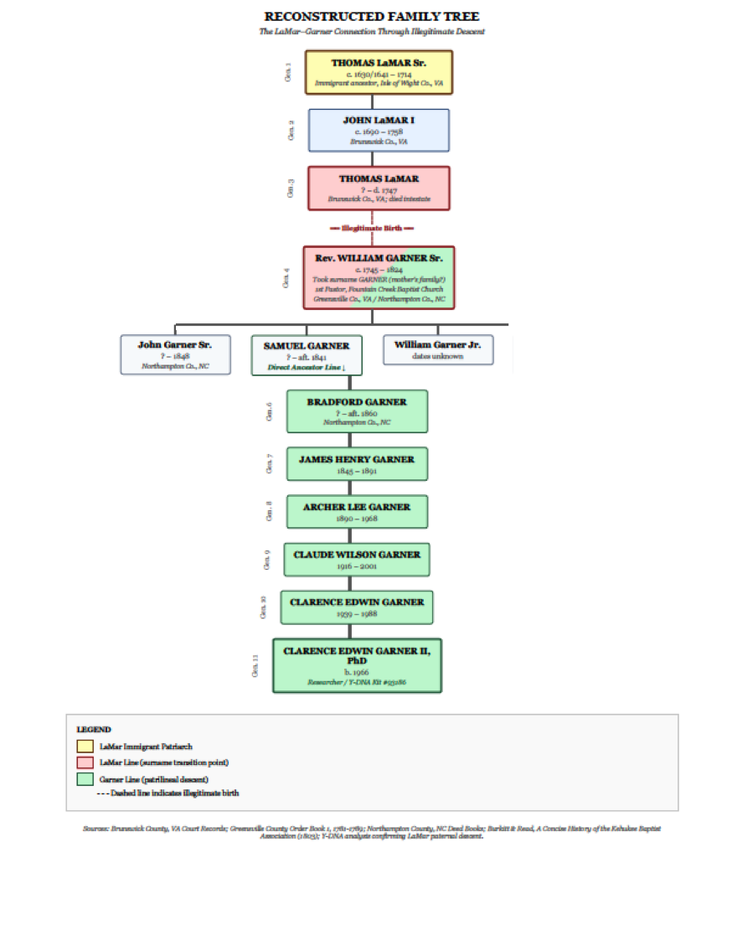

*Figure 21. Reconstructed family tree showing the connection between the LaMar and Garner lines through Thomas LaMar (d. 1747) and his illegitimate son William Garner (c. 1745-1824).*

## 11.4 Significance

This research demonstrates the power of combining Y-DNA analysis with traditional documentary research to break through genealogical brick walls. The Garner paper trail dead-ended in the 1750s because **there was no legitimate Garner paternal line to trace**—William Garner's biological father was Thomas LaMar, and the Garner surname came through his mother per Colonial traditions.

For descendants of Rev. William Garner, this finding:

* Extends the documented patrilineal ancestry by approximately 100 years (to 1630/1641)
* Establishes French Huguenot origins through the Lamar family
* Explains the previously inexplicable genealogical brick wall
* Opens new avenues for research through the documented LaMar lineage
* Establishes Rev. William Garner's distinct Revolutionary War service as a Patriot
* Identifies Samuel Garner as a biological brother, expanding the known family network
* Connects the Virginia/North Carolina Garners to the South Carolina branch (Presley Garner, Garner's Ferry)
* Definitively distinguishes Rev. William Garner Sr. from William Garner (d. 1805 KY) through geographic, documentary, and genetic evidence
* Identifies four Garner plantation sites near Gaston, NC through 1864 Gilmer Map analysis
* Confirms naming tradition through Dr. Presley Killingsworth Garner's grave (1835-1861), proving the name "Presley" was honored in the direct line
* Documents multi-generational prosperity through the 1825 James Garner Manor House and family sawmill operations

# Appendix: Sources and References

## Primary Sources

* Family Tree DNA Y-DNA Results (700 Marker Test) — Garner/LaMar match
* Family Tree DNA Y-DNA Results (11 Marker Test) — Garner (William Sr.)/Garner (Samuel) match
* Thomas LaMar Will, Prince George's County, Maryland, 1747 (Maryland Wills, Vol. 25-28)
* Frederick County, Maryland Orphans Court Records, 1748-1765
* John Garner Will, Calvert County, Maryland, 1721 (Probated 1722)
* Rev. William Garner Will, Northampton County, North Carolina, 1824
* Halifax County, NC Revolutionary War Voucher, 1781 ("William Garner of Northampton County" — 6 lbs sterling)
* Brunswick County, VA Public Service Claims (beef driving, 1780 — 6 lbs for 40 days service)
* Greensville County Patriots List (D.A.R. Magazine, Vol. 68, 1934; Virginia Archives)
* William Garner Letter to Isaac Backus, February 16, 1797 (Isaac Backus Collection, Newton-Andover Theological Seminary, Harvard University)
* Tucker Petition, Northampton County, NC, 1818 (signature comparison)
* Northampton County, NC Deed Books
* Brunswick County, VA Deed Books
* Greensville County, VA Order Books
* St. George's Parish Vestry Minutes, Northampton County, NC, 1773-1776
* Sally Garner Goodrum Deposition, Warren County, KY, 1849 (Revolutionary War Pension Records, Virginia R4120)
* Northampton County Tax List, 1780
* Greensville County Partition Petition, 1787 (signed by William Garner, Samuel Garner, Presley Garner)
* Samuel Garner Will (registered Chatham County, died Northampton County, NC)
* Presley Garner Estate Settlement, Richland County, SC, 1838 (Will Book D, page 306)
* Samuel Garner Will, 1809 (Chatham County Will Book B, p. 130)
* Brunswick County VA Tax List, 1788 (List B Property Taxes)
* Gilmer Map 44 (1864), Confederate Army Chief Engineer's Office
* USGS Topographical Map, Gaston, NC Quadrangle
* Killingsworth Family Registry, Surry County VA origins (Farrand, Kemp, Dyckman, Gornik, and Case Families database)
* Northampton County Index to Land Purchases, Garner Family 1741-1922
* Garner/Gardner Y-DNA Project data (Family Tree DNA)
* U.S. Census, Surry County, NC, 1790 and 1800
* U.S. Census, Northampton County, NC, 1850 and 1860
* Rutherford County Court Records, 1798-1799 (Genealogical Society of Old Tryon County Quarterly)
* Rutherford County Deed Book 24 (1806-1808)
* Rutherford County Estate Records, 1819-1821 (Genealogical Society of Old Tryon County)
* Rutherford County Road Records, 1792-1795
* Northampton County Court of Pleas and Quarter Records 1834-1836 (CR071.326.15)
* Northampton County Loose Estate Records (CR 071.508.76, CR 071.508.77)
* North Carolina Troops 1861-65, A Roster (Confederate military records)
* Thomas Garner Will, 1837 (Northampton County Will book WB-4/160)
* Interview with Presley Killingsworth Bradley, July 13, 2002
* Raymond Garner Affidavit, August 8, 1977 (notarized by O. Max Gardner Jr., Halifax County, NC)
* Clarence Garner Family Bible (births, marriages, marriage certificate)
* "The Garner Farm" article, submitted by Claude Garner
* Archer L. Garner Obituary (Roanoke Rapids newspaper)
* Gilmer Map 44, Confederate Army Chief Engineer's Office, 1864 (Greensville County, VA and Northampton County, NC)
* USGS Topographical Maps, Gaston Quadrangle, Northampton County, NC
* Dr. Presley Killingsworth Garner Gravestone (1835-1861), Gaston, NC (Site B)
* Henry Garner Cemetery Transcription, Gaston, NC (Site C) — Henry Garner (1807-1879), Sarah Jane Garner (1804-1864), et al.
* James Garner Manor House Chimney Inscription "James Garner built 1825" (Site C, demolished 1990s)

## Secondary Sources

* Garner, C. Edwin. "Reverend William Garner, Sr. (1745-1824): Planter of Northampton County, NC and Greensville County, VA." Unpublished manuscript, 2008.
* Garner, C. Edwin. "William Garner, Early Baptist Pioneer." Chapter 6, unpublished manuscript, 2009.
* Garner, C. Edwin. "A Biographical Sketch of Presley Garner of Greensville County Va and Richland County, SC: Revolutionary War Seaman and Planter." Unpublished manuscript, 2009.
* Garner, C. Edwin. "Notes on Samuel Garner of Brunswick." Research notes, unpublished.
* Burkitt, Lemuel and Jesse Read. *A Concise History of the Kehukee Baptist Association.* Halifax, NC, 1803; revised Philadelphia, 1850. Pages 282-283 (Fountain Creek Church).
* Byrd, William. "History of the Dividing Line." 1967 edition.
* Boddie, John Bennett. "Historical Southern Families." Various volumes.
* Lewis, Harold F. "Anglican Church Records of Northampton County, NC." 1951.
* Nelson and Nelson. "History of Fountain Creek Baptist Church." 1987.
* Burkitt, Lemuel and Jesse Read. *A Concise History of the Kehukee Baptist Association, from its original rise down to 1803.* Halifax, NC: A. Hodge, 1803. (Original edition; revised by Henry L. Burkitt, Philadelphia: Lippincott, Grambo and Co., 1850.)
* Minutes of the Portsmouth Association, 1791-1804.
* Minutes of the Meherrin Association, 1804-1815.
* St. George's Parish Vestry Records, Northampton County, NC (Clerk of St. John's Chapel, October 1773).
* Hassell, Cushing Biggs and Sylvester Hassell. "History of the Church of God, from the Creation to A.D. 1885." 1886; reprint 1973.
* Semple, Robert B. "History of the Rise and Progress of the Baptists in Virginia." 1894.
* Simpson, William. Research notes on early Baptist ministry in Greensville/Northampton, Virginia Baptist Historical Society. 2004.
* Knorr, Catharine. "Marriages of Greensville County Virginia and Ministers Returns 1781-1825." 1955.
* Brumbaugh, Gaius Marcus. "Revolutionary War Records, Volume 1." Lancaster, PA: Lancaster Press, Inc., 1936.
* Lossing, Benson J. "Pictorial Field Book Of The Revolution, Volume II." Harper Brothers, New York, 1850.
* Mills' Atlas of South Carolina, 1825 (Richland County — Garner's Ferry, Garner's Quarter, Garner's Mill, Garner's Lake)
* Garner, C. Edwin. "Locations of the Plantations of William Garner and Family." Excerpted from Planter of Northampton County, NC and Greensville County, VA. Unpublished manuscript, 2008.

## Maps Consulted

* Gilmer Map 44, Confederate Army Chief Engineer's Office, 1864 — Greensville County, VA and Northampton County, NC (identifies four Garner plantation sites)
* USGS Topographical Maps, Gaston Quadrangle — identifies Garners Mill, cemetery locations, modern road names
* Jefferson Map of Virginia, 1755
* Moseley Map of North Carolina, 1733
* Collet Map of North Carolina, 1770
* Mouzon Map, 1775
* Gilmer Map 44 (Civil War era), 1864

*— End of Document —*